EXPLORING BEHAVIOURAL SYNDROMES AND PERSONALITY TRAITS IN AMPHIBIAN LARVAE

H.T.D. Rajapaksha (S/19/135)

HONOURS DEGREE STUDENT PROJECT REPORT
DEPARTMENT OF ZOOLOGY
UNIVERSITY OF PERADENIYA 2025
EXPLORING BEHAVIOURAL SYNDROMES AND PERSONALITY TRAITS IN AMPHIBIAN LARVAE

A project report submitted by
H.T.D. Rajapaksha

To the Department of Zoology, Faculty of Science,
University of Peradeniya, Sri Lanka
In partial fulfilment of the requirements of the,
Bachelor of Science Honours Degree in Zoology

----------------------------------
Dr N. U. K. Pathirana

Department of Zoology
Faculty of Science
University of Peradeniya

----------------------------------
Prof. Suyama Boyagoda

Head/Department of Zoology
Faculty of Science
University of Peradeniya
University of Peradeniya -2025
Table of Contents

List of Figures iii
List of Tables iv
List of Abbreviations v
ACKNOWLEDGEMENTS vii
ABSTRACT viii
1. INTRODUCTION 1
1.1. Animal Personality and Behavioural Syndromes 1
1.2. Physiological and Genetic Mechanisms Underlying Personality 1
1.3. Amphibians as a Model for Behavioural Research 2
1.4. Knowledge Gaps and the Tropical Context 3
1.5. Study Species and Rationale 4
1.6. Research Objectives 6
1.6.1 Overall Objective: 6
1.6.2 Specific Objectives: 6
1.7 Hypothesis 6
2. MATERIALS AND METHODS 7
2.1 Study Sites 7
Figure 2.1 (a) Eggs of Polypedates cruciger (b) Eggs of Duttaphrynus melanostictus 7
2.2 Maintenance of Tadpole Larvae 7
2.3 Behavioural Experiments 8
Figure 2.4 a) The custom Python script used for the tracking of the tadpoles b) The tadpole displayed with a yellow colour tracking box during the analysis. 10
2.3.1 Emergence Test 11
2.3.2 Open Field Test 11
2.3.3 Novel Object Test 12
2.3.4 Mirror Test 13
2.4 Data Analysis 14
2.5 Ethical Considerations 15
3. RESULTS 15
3.1 Repeatability of Behavioural Traits 15
3.2 Correlations of Behavioural Traits 18
4. DISCUSSION 29
5. REFERENCES 36

List of Figures

Figure 2.1 (a) Eggs of Polypedates cruciger (b) Eggs of Duttaphrynus melanostictus 7
Figure 2.2 Timeline of the short-term experimental procedure emergence test (ET), mirror test (MT), novel object test (NOT), open field test (OFT) 9
Figure 2.3 Timeline of the long-term experimental procedure emergence test (ET), mirror test (MT), novel object test (NOT), open field test (OFT) 9
Figure 2.4 a) The custom Python script used for the tracking of the tadpoles b) The tadpole displayed with a yellow colour tracking box during the analysis…………………………………10
Figure 2.5 a) Schematic diagram of the arena, showing shelter area with an artificial plant, small stones and a movable door to provide access from the shelter to the rest of the tank. Risky zone was segmented manually b) Photograph during pilot study with Duttaphrynus melanostictus tadpole in the open field area……………………………………………………………………11
Figure 2.6 a) Schematic diagram of the arena used for novel object test. b) and c) Photographs taken from the video recordings of novel object tests with two different objects……………..12
Figure 2.7 a) Schematic diagram of the arena used for mirror test b) Photographs taken from the video recordings of the mirror test 13
Figure 3.1 a) Within-individual (above diagonal) and among-individual (below diagonal) correlations between behavioural variables in Polypedates cruciger short-term 23
Figure 3.1 b) Within-individual (above diagonal) and among-individual (below diagonal) correlations between behavioural variables in Polypedates cruciger long- term 23
Figure 3.2 a) Within-individual (above diagonal) and among-individual (below diagonal) correlations between behavioural variables in Duttaphrynus melanostictus short-term 28
Figure 3.2 b) Within-individual (above diagonal) and among-individual (below diagonal) correlations between behavioural variables in Duttaphrynus melanostictus long-term........ 28

List of Tables

Table 2.1 The behavioural traits measured, and the procedures used to measure them in Polypedates cruciger and Duttaphrynus melanostictus larvae 8
Table 3.1 Repeatability estimates (with 95% credible intervals in parentheses) for each personality trait in common hourglass frog (Polypedates cruciger) measured across short-term (n = 50) and long-term time periods (n= 50) 16
Table 3.2 Repeatability estimates (with 95% credible intervals in parentheses) for each personality trait in common toad (Duttaphrynus melanostictus) measured across short-term (n = 50) and long-term time periods (n = 50) 17
Table 3.3 Within individual, among individual and overall phenotypic correlations (with 95% credible intervals in parentheses) between behavioral variable in common hourglass frog (Polypedates cruciger) measured across short-term (n = 50) and long-term time periods (n=50) 20
Table 3.4 Within individual, among individual and overall phenotypic correlations (with 95% credible intervals in parentheses) between behavioral variable in common toad (Duttaphrynus melanostictus) measured across short-term (n = 50) and long-term time periods (n=50) 25

List of Abbreviations

ET – emergence test
OFT – open field test
NOT – novel object test
MT – mirror test
TL – track length
RZ – time spent in risky zone
ET – emergence time
LA – latency to approach an object
TS – time spent near object
CV – time spent near mirror
AT – number of attacks towards mirror
CM – latency to approach mirror
Avoid – number of avoidances done away from the mirror
Expo – number of movements done parallel to the mirror.
POLS – Pace of Life Syndrome

ACKNOWLEDGEMENTS
First and foremost, I would like to express my sincere and heartfelt gratitude to my supervisor, Dr. Nuwandi Pathirana, for her exceptional guidance, encouragement, and continuous support throughout the course of this research. Her dedication, expertise, and patience have been truly inspiring. I am also deeply thankful to Prof. Suyama Boyagoda, Head of the Department of Zoology, for providing the essential facilities required to carry out this study.
I also thank Mr. Buddika Dissanayake (EWE International AG, Wiener Neudorf, Austria) and Mr. Goyum Wickramasinghe (Department of Physical Sciences, Faculty of Applied Sciences, South Eastern University of Sri Lanka) for developing the Python script used for the behavioural analyses. My heartfelt thanks go to Prof. Uthpala Jayawardhana and Mr. Kumudu Wijesooriya for their assistance in resolving issues related to the samples. I am also grateful to the Director and staff of the Royal Botanical Garden, Peradeniya, as well as Ms. Vidarshana Sammani and her family, for their support in the collection of samples.
Thank you Miss. Shamali Herath for being with me and helping me from the beginning of this process. I extend my sincere appreciation to Mr. Pasindu Maduranga for his help with the statistical analysis, and to Mr Dilshan Pathirana for providing valuable technical support. My thanks also go to Mr. Lakshitha Dewananda, and Mrs. Gayathri Madurangi Hewagamage for their continuous encouragement and assistance throughout the research process.
Finally, I would like to express my deepest and most heartfelt gratitude to my mother, father, and brother and Mr. Chamath Jayoda Gamage. Their unconditional love, encouragement, and belief in me have been the foundation of my strength. My family has always stood by me through every challenge, celebrated every small success, and supported my academic journey with endless patience and understanding. I am truly blessed and eternally grateful to have a family that inspires me, motivates me, and makes it possible for me to pursue my dreams. Thank you so much for everything.

ABSTRACT

Understanding consistent individual differences in behaviour, or animal personality, and their ecological significance is fundamental for interpreting species interactions, competitive dynamics, and developmental trajectories. This study provides the first comprehensive assessment of repeatability (personality) and behavioural syndromes (correlations) in the larval stages of two sympatric Sri Lankan anurans: the endemic Polypedates cruciger and the widespread Duttaphrynus melanostictus. Using repeated short- and long-term behavioural assays and multivariate mixed-effects models, we quantified repeatability in key behavioural traits including boldness, exploration, sociability, aggression, and activity, and examined inter-trait correlations at phenotypic, within-individual, and among-individual levels to characterize behavioural syndromes. Polypedates cruciger exhibited low-to-moderate short-term repeatability but high long-term repeatability across exploration, sociability, and boldness, while activity and risky-zone use remained non-repeatable. Correlation analyses revealed strong positive phenotypic and among-individual associations among exploration and sociability traits, together with within-individual trade-offs between activity and sociability and between boldness and sociability, indicating a structured proactive-like behavioural syndrome. In contrast, D. melanostictus displayed exceptionally high short-term repeatability in exploration, sociability, and boldness, which declined over the long term, while aggression increased in repeatability. Correlations were generally weaker and more diffuse but included positive phenotypic, within-individual, and among-individual associations linking exploration, sociability, boldness, and aggression, reflecting flexible yet integrated behavioural syndromes. Activity and risky-zone use were non-repeatable in both species. These species-specific patterns of repeatability (personality) and behavioural syndromes (correlations) correspond with ecological specializations, competitive strategies, and developmental trajectories, providing mechanistic insight into asymmetric competition and establishing essential baseline data for amphibian behavioural ecology, ontogenetic development, and conservation management.

Keywords: Activity, Behaviour, Duttaphrynus melanostictus, Polypedates cruciger, Repeatability

INTRODUCTION

Animal Personality and Behavioural Syndromes

Over the past several decades, research in animal behaviour has shifted from reliance on population-level averages to recognizing the importance of consistent individual differences. These stable differences in behaviour are now widely conceptualized as animal personality, reflecting repeatable traits that persist over time and across contexts (Wilson et al., 1994; Kelleher et al., 2018). Core personality traits such as boldness, aggression, exploration, activity, and sociability influence how individuals interact with their environment, affect ecological interactions, and contribute to fitness outcomes (Réale et al., 2007; Bell et al., 2009). Unlike transient behavioural responses, these traits represent intrinsic tendencies underpinned by genetic, physiological, and cognitive mechanisms, making them central to behavioural ecology (Wolf and Weissing, 2012; Dingemanse et al., 2010).
A closely related concept, behavioural syndromes, refers to suites of correlated behaviours consistently expressed across multiple contexts (Sih et al., 2004). For example, individuals that are bold in predator encounters may also be aggressive during competition or more exploratory while foraging. These syndromes are maintained through ecological and evolutionary pressures, revealing functional associations among traits and constraining or facilitating behavioural plasticity (Bell et al., 2007; Kelleher et al., 2018). One widely studied example is the proactive-reactive axis, where proactive individuals are typically more active, bold, and exploratory, while reactive individuals are more cautious and flexible (Sih et al., 2004; Koprivnikar et al., 2012; Ferrari et al .,2013). Behavioural syndromes can therefore directly influence survival, growth, reproductive success, and susceptibility to predation or parasitism (Urszán et al., 2015).

1.2. Physiological and Genetic Mechanisms Underlying Personality
Animal personality traits are closely linked to underlying physiological, genetic, and neurobiological mechanisms. Metabolic rate, for instance, has been associated with activity and boldness, while neuroendocrine responses, including glucocorticoid and serotonin pathways, mediate coping strategies and aggression (Biro et al., 2008; Koolhaas et al., 1999). Cognitive traits such as cerebral lateralization and learning ability also contribute to consistent behavioural differences (Reddon et al., 2009). Early developmental experiences, including maternal effects, resource availability, predator exposure, or parasitic infection, can shape enduring behavioural trajectories, sometimes via epigenetic mechanisms (Crews and Mclachlan, 2006; Burlibasa et al., 2011).
Quantifying personality relies on metrics such as repeatability, the proportion of behavioural variance attributable to individual differences (Lessells et al., 1987; Dingemanse et al., 2013). High repeatability supports the presence of distinct personalities, whereas low repeatability indicates plastic or context-dependent behaviour. Across taxa, including mammals, birds, reptiles, fish, and invertebrates, high repeatability of behaviour has been demonstrated, confirming the ecological and evolutionary relevance of personality (Réale et al., 2010; Martins et al., 2012; Pathirana et al., 2025).

1.3. Amphibians as a Model for Behavioural Research
Amphibians are increasingly recognized as valuable models for studying personality and behavioural syndromes due to their unique biphasic life cycles, which include aquatic larval and terrestrial or semi-terrestrial adult stages. This ontogenetic transition provides opportunities to assess behavioural consistency across development and to examine how ecological pressures shape individual differences (Kelleher et al., 2018). Larval amphibians are experimentally tractable: they can be produced in large numbers, are easy to rear under controlled conditions, and respond sensitively to environmental variability (Burlibasa et al., 2005).
Amphibian larvae experience dynamic ecological pressures, including predation, competition, parasitism, and resource fluctuations, making them ideal for studying context-dependent behavioural strategies (Szuroczki and Richardson, 2012; Koprivnikar et al., 2012). Their permeable skin and complex life cycles make them highly sensitive to environmental disturbances, positioning them as effective bio indicators of ecosystem health (Walls and Gabor, 2019). Recent studies have documented repeatable differences in larval boldness, activity, exploration, and social behaviour across species such as Lithobates sylvaticus, Ambystoma maculatum, Rana dalmatina, and bullfrogs (Lithobates catesbeianus) (Kelleher et al., 2018; Bégué et al., 2023; Koprivnikar et al., 2012; Adam et al., 2018; Urszán et al., 2015).

1.4. Knowledge Gaps and the Tropical Context
Despite substantial progress in understanding animal personality and behavioural syndromes, important gaps remain in amphibian research, particularly within tropical ecosystems. Most studies on personality traits have been conducted in temperate regions and on a limited set of model species, leaving tropical amphibians often highly diverse and ecologically specialized largely understudied (Kelleher et al., 2018; Koprivnikar et al., 2012). Tropical ecosystems present unique challenges and selective pressures, including high species richness, complex predator-prey networks, intense competition for limited resources, and pronounced temporal environmental variability. These factors may shape behavioural trait expression in ways that differ substantially from temperate systems, highlighting the need for focused research in these regions.
Larval amphibians in tropical environments face a variety of ecological stressors that can influence personality and behavioural syndromes. Predation is a major selective force, with invertebrate predators, fish, and other amphibians exerting pressure on larvae (Relyea, 2001; Szuroczki and Richardson, 2012). The intensity of predation may select for specific behavioural strategies, such as boldness to secure resources versus cautious behaviour to avoid detection. However, how these selective pressures interact with consistent individual differences is not fully understood, particularly in species with contrasting life histories. Similarly, resource distribution and competition can influence activity and exploratory behaviour, with individuals differing in their propensity to exploit novel habitats or food patches. In tropical ponds and streams, resource availability can fluctuate dramatically due to rainfall patterns, seasonal water flow, and nutrient inputs, creating variable ecological contexts in which personality traits are expressed (Koprivnikar et al., 2012; Bégué et al., 2023).
Parasitism and disease add another layer of complexity to larval behavioural ecology. Parasitic infections can modify host behaviour through physiological stress, altered energy allocation, or neurological effects, potentially impacting survival and growth (Pathirana et al., 2025). Despite growing evidence in other vertebrate taxa that parasites can influence personality, few studies have examined these effects in tropical amphibians, leaving a critical gap in understanding the ecological drivers of behavioural variation. Additionally, the interaction between parasitism, predation, and resource competition may generate context-dependent behavioural responses, emphasizing the need for integrative studies that combine ecological, physiological, and behavioural perspectives.
Climate and environmental variability are particularly salient in tropical regions. Amphibian larvae are highly sensitive to changes in water temperature, ph, and hydrological patterns, with potential consequences for metabolic rate, activity levels, and behavioural syndromes (Walls and Gabor, 2019). Extreme weather events, such as droughts and floods, can alter pond connectivity, larval density, and predation risk, creating shifting selective landscapes for behaviour. Despite these pressures, there is limited empirical research on how consistent individual differences in behaviour are maintained under fluctuating tropical conditions, or how plasticity interacts with intrinsic personality traits to influence fitness outcomes.
Tropical amphibians also display remarkable phenotypic and developmental plasticity, yet the mechanisms linking early-life environmental conditions to adult behavioural traits remain poorly characterized. Epigenetic modifications, maternal effects, and early exposure to stressors can shape the emergence and stability of personality traits, but evidence from tropical systems is scarce (Waddington, 1953; Crews and Mclachlan, 2006; Godin et al., 2012). Integrating these developmental perspectives with behavioural assays is essential for understanding the ontogeny of personality and the potential for transgenerational inheritance of behavioural traits.
Sri Lanka, as a tropical biodiversity hotspot with high levels of amphibian endemism, exemplifies both the urgency and opportunity for such research. While taxonomic and conservation assessments are extensive, behavioural ecology remains largely unexplored, limiting our ability to predict species responses to habitat alteration, pollution, invasive species, and climate change (Manamendra-Arachchi and Pethiyagoda, 2006). Investigating personality traits and behavioural syndromes in this context provides critical insights into how individual-level behavioural variation contributes to population resilience, ecological interactions, and long-term persistence in rapidly changing environments.

1.5. Study Species and Rationale
This thesis addresses the identified gaps by systematically examining behavioural syndromes and personality traits in the larvae of two anuran species: common hourglass frog (Polypedates cruciger), endemic to Sri Lanka, and Common toad (Duttaphrynus melanostictus), and a widespread species across Asia. These species were selected due to their contrasting reproductive strategies, larval ecologies, and habitat preferences, which provide an ideal framework for comparative behavioural research. Polypedates cruciger deposits eggs in foam nests attached to vegetation above water bodies, resulting in larvae that fall into the water upon hatching. This reproductive mode exposes larvae to specific microhabitat conditions, including variation in predation pressure, water chemistry, and resource availability. In contrast, D. melanostictus lays eggs as aquatic gelatinous strings directly in the water, producing larvae that are immediately immersed in the aquatic environment, where they experience different spatial distributions, competition levels, and predator interactions (Khan, 1982; Manamendra-Arachchi and Pethiyagoda, 2006).
These differences in reproductive strategy and larval ecology are expected to influence not only the expression of individual behavioural traits but also the structure of behavioural syndromes. For instance, foam-nesting species may favour larvae that exhibit rapid escape responses and high exploration to locate food or avoid predators, whereas larvae from gelatinous strings may display more cautious behaviour due to higher exposure to conspecific competition and predators. By examining these two species in parallel, this study can explore how life-history traits and early ecological experiences shape personality traits and their repeatability over time.
Furthermore, both species occupy overlapping habitats in parts of Sri Lanka, enabling an assessment of intra- and inter-specific variation in response to similar environmental pressures (Ukuwela & Ranawana, 2011). Such sympatric comparisons are valuable for disentangling the relative contributions of species-specific evolutionary strategies and immediate ecological context to behavioural variation. Investigating these differences in larval behaviour is particularly important because larval stages represent a critical period for survival and growth, which ultimately influences metamorphic success, adult fitness, and population dynamics.
From a conservation perspective, P. cruciger represents an endemic species highly vulnerable to habitat alteration and climate change, while D. melanostictus is widespread and resilient. Understanding how personality traits and behavioural syndromes manifest in these larvae provides insight into potential adaptive strategies that influence survival under environmental stress. This information is critical for conservation management in tropical biodiversity hotspots, where habitat fragmentation, pollution, and invasive species threaten endemic amphibians.
Additionally, the study of larval behaviour in these two species contributes to broader ecological and evolutionary theory. Behavioural syndromes and consistent individual differences have been shown to affect dispersal, resource use, competitive interactions, and susceptibility to predation and parasitism in other taxa. By documenting these patterns in tropical amphibian larvae, this thesis can inform both fundamental behavioural ecology and applied conservation practices, such as habitat restoration, captive breeding programs, and population monitoring.

1.6. Research Objectives

1.6.1 Overall Objective:
To explore behavioural syndromes and personality traits in amphibian larvae (Polypedates cruciger and Duttaphrynus melanostictus).

1.6.2 Specific Objectives:
1. To assess the repeatability and consistency of behavioural traits activity, boldness, exploration, sociability, and aggression in P. cruciger and D. melanostictus larvae.
2. To examine intra- and inter-specific correlations between behavioural syndromes and personality traits in P. cruciger and D. melanostictus larvae.
3. To evaluate short-term and long-term behavioural consistency in P. cruciger and D. melanostictus larvae through a series of behavioural assays.

1.7 Hypothesis
- There is a repeatability and consistency of behavioural syndromes and personality traits in selected anuran species.
- Consistent individual differences in behavioural traits (personality) across species will form behavioural syndromes, and these syndromes will be influenced by both inter- and intra- specific interactions and environmental pressures.
- Amphibian larvae exhibit consistent individual traits (personality traits) over both short-term (within days) and long-term (across developmental stages) periods.

MATERIALS AND METHODS

2.1 Study Sites
Sampling of Polypedates cruciger and Duttaphrynus melanostictus eggs (Figure 2.1a & b) was conducted at two locations in Kandy, Sri Lanka: the Royal Botanical Garden (Latitude: 7°16' 9.60" N, Longitude: 80°35' 26.39" E) and the University of Peradeniya premises (Latitude: 6.9737° N, Longitude: 79.9153° E). These sites were selected based on the accessibility of breeding populations and the presence of suitable aquatic microhabitats for egg deposition.
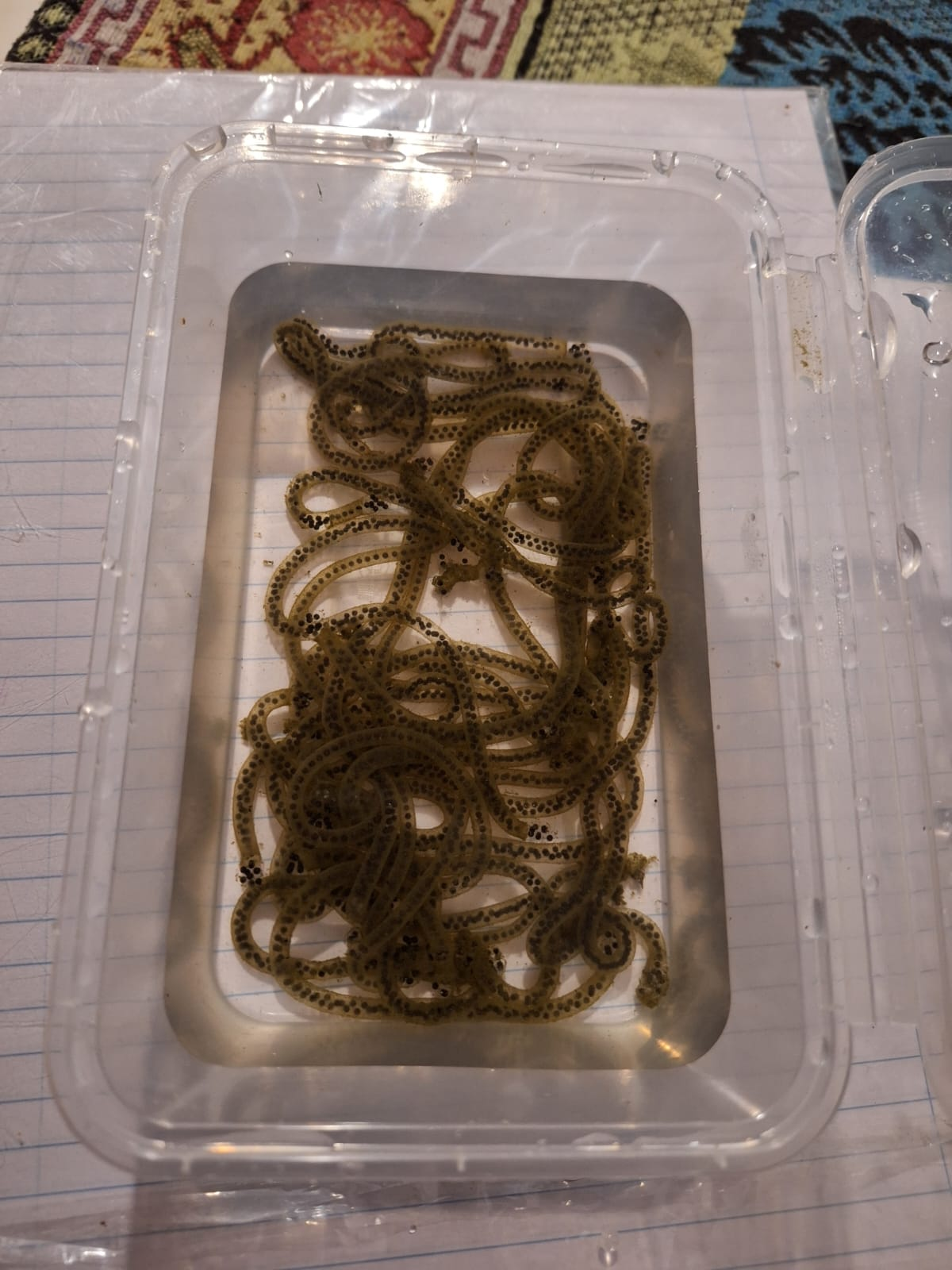
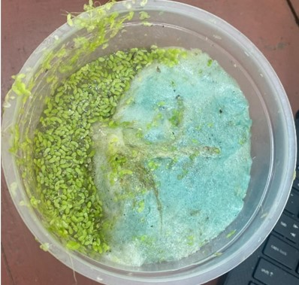
- (b)

Figure 2.1 (a) Eggs of Polypedates cruciger (b) Eggs of Duttaphrynus melanostictus

2.2 Maintenance of Tadpole Larvae
Eggs of both species were collected from their natural habitats and transported to the laboratory in plastic containers filled with water from the collection sites. The eggs were allowed to hatch under laboratory conditions. From each species, fifty tadpoles at ten days post-hatch were selected for experiments. Initially, tadpoles were housed together in a single tank (61 × 31 × 31 cm) for one week. Subsequently, individual tadpoles were transferred to separate isolation tanks (32 × 14 × 14 cm) for three days. Individual housing allowed for identification without the stress of marking and ensured standardized living conditions while preserving visual contact between tadpoles (Frederick, 1997; Ploverino et al., 2016).
Tadpoles were maintained under a 12:12 light-dark photoperiod at 27–29 °C. They were fed 2.0 g of commercial fish food daily, and aged, de-chlorinated tap water was used, replaced weekly. Tadpoles were acclimatized for three days prior to behavioural testing.

2.3 Behavioural Experiments
Five personality traits activity, boldness, exploration, sociability, and aggression were assessed using four behavioural assays: The Open Field Test (OFT), Emergence Test (ET), Novel Object Test (NOT), and Mirror Test (MT) (Table 2.1).
Table 2.1 The behavioural traits measured, and the procedures used to measure them in Polypedates cruciger and Duttaphrynus melanostictus larvae
Behavioral trait | Putative personality trait | Procedure
Track length (TL) | Activity | Open field test
Time spent in the risky zone (RZ) | Boldness | Open field test
Emergence time (ET) | Boldness | Emergence test
Time spent near the object (TS) | Exploration | Novel object test
Latency to approach the object (LA) | Exploration | Novel object test
Time spent closer to mirror (CV) | Sociability | Mirror test
No of attacks done towards the mirror (AT) | Aggression | Mirror test
Movements done parallel do the mirror (Expo) | Exploration | Mirror test
No of avoidances done away from the mirror (Avoid) | Aggression | Mirror test

Seven behavioural variables corresponding to the personality traits were recorded for both P. cruciger and D. melanostictus tadpoles. Behavioural assays were conducted in both short-term and long-term experimental designs (Figure 2.2 and Figure 2.3).
Short-term tests were performed across four time points, with a one-day rest between tests and a one-week rest between time points (Figure 2.2). Long-term tests consisted of three or four time points, depending on larval morphology, with one-day rests between tests and a three-week interval between time points (Figure 2.3).

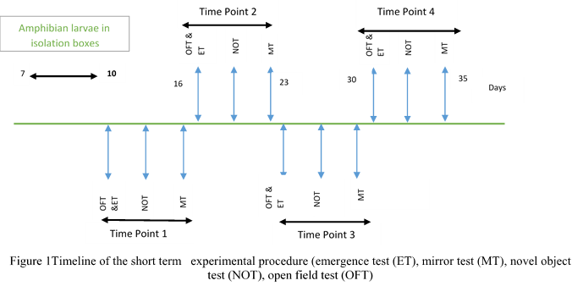
Figure 2.2 Timeline of the short-term experimental procedure emergence test (ET), mirror test (MT), novel object test (NOT), open field test (OFT)
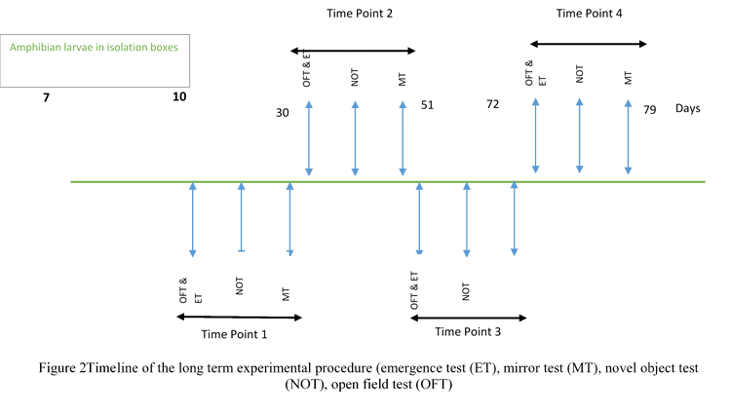
Figure 2.3 Timeline of the long-term experimental procedure emergence test (ET), mirror test (MT), novel object test (NOT), open field test (OFT)
The purpose of the four behavioural tests was to assess multiple personality traits and examine correlations among them. The ET measured latency to emerge from a shelter, reflecting boldness, and allowed assessment of boldness-activity syndromes. The OFT quantified activity and boldness, as well as activity-exploration and activity-boldness behavioural syndromes. The NOT evaluated exploration and interspecies differences in novelty response. The MT assessed sociability, aggression, exploratory versus avoidance behaviour, and responses to perceived threats, allowing evaluation of intra- and interspecies social responsiveness. All behavioural assays were conducted between 08:00 and 16:00 in tanks (32 × 14 × 14 cm) filled with 6 cm of water. Tanks were covered with translucent polythene to prevent visual disturbances, and water temperature was maintained at 27–29 °C. Tadpole behaviour was recorded using a high- resolution HD camera (60 fps) mounted 1 m above the tanks. Videos were analysed using a specialized custom Python script developed in collaboration with research partners (Figure 2.4 a &b)
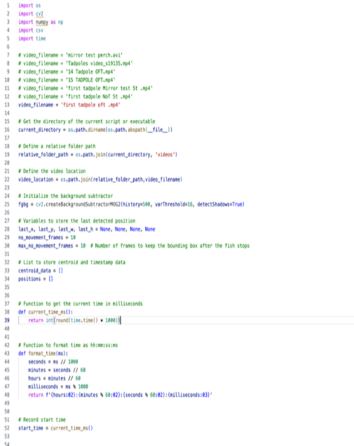 | 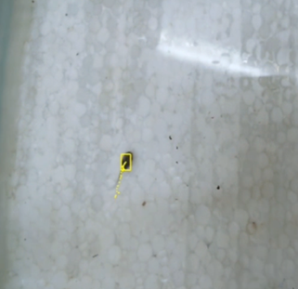

- (b)

Figure 2.4 a) The custom Python script used for the tracking of the tadpoles b) The tadpole displayed with a yellow colour tracking box during the analysis.

2.3.1 Emergence Test
Tadpoles were placed in a shelter area containing a small plastic plant and three stones. After a 3-minute acclimatisation, latency to emerge from the shelter (ET) was recorded using a stopwatch, and behaviour was video-recorded for analysis. The emergence of amphibian larvae from the shelter was observed using the camera connected to a computer.

2.3.2 Open Field Test
The shelter door was closed after they came out of the shelter. The behaviour of the amphibian larvae was filmed for 5 minutes using the camera (Figure 2.5 a & b). The track length (TL) and the amount of time spent in the risky zone (RZ) were analysed by using the videos and the software. Risky zone is an area located away from the surfaces, segmented using the customized Python script which was used in the experiment. After this amphibian larvae were captured and returned to their isolation tanks (Figure 2.5 a & b).
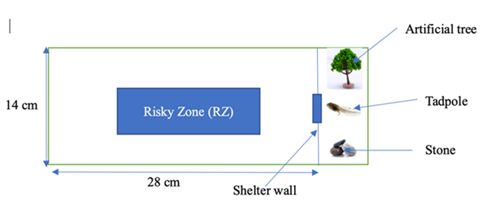  14 cm | 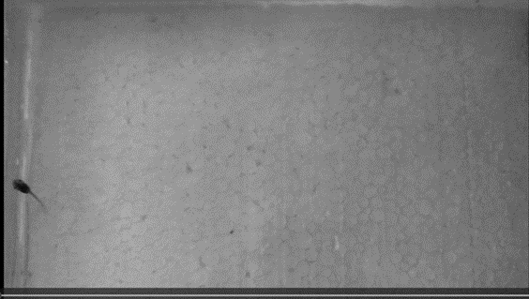
28 cm
- (b)
Figure 2.5 a) Schematic diagram of the arena, showing shelter area with an artificial plant, small stones and a movable door to provide access from the shelter to the rest of the tank. Risky zone was segmented manually b) Photograph during pilot study with Duttaphrynus melanostictus tadpole in the open field area.

2.3.3 Novel Object Test
Amphibian larvae were taken individually and gently placed in the middle of the experimental tank with dimensions 32 x 14 x 14 cm with water filled up to 6.0 cm (Figure 2.6 a & b and c) The larvae were allowed to acclimatize for 3 minutes. A blue pebble (2.5 cm length x 0.5 cm width) at the time point – 1, a coin (2 cm radius) at the time point – 2, a red piece of Lego (3 cm radius, 5 cm height) at the time point – 3 and a blue, small ball (radius 1.5 cm) at the time point 4 were introduced to the tank and the behaviour of the amphibian larvae were observed for 10 minutes using the camera (Figure 2.6 a & b and c). The analysis of the video was done by using the software to find out the latency to approach the object (LA) and track length (TS). After this amphibian larvae were captured and returned to their isolation tanks.
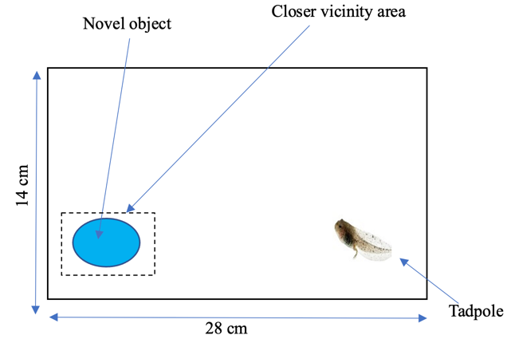
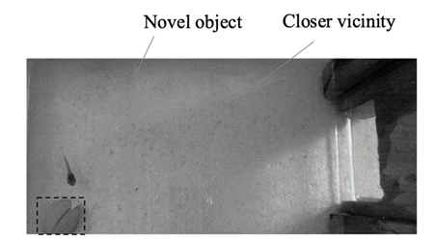
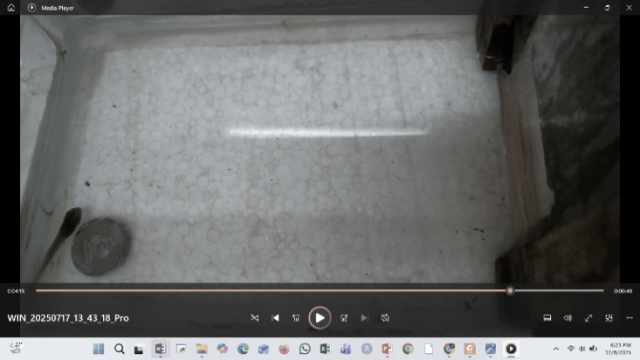
(a)
28 cm
14 cm

28 cm
14 cm kakkCccccccccccm
(b) | (c)

Figure 2.6 a) Schematic diagram of the arena used for novel object test. b) and c) Photographs taken from the video recordings of novel object tests with two different objects.

2.3.4 Mirror Test
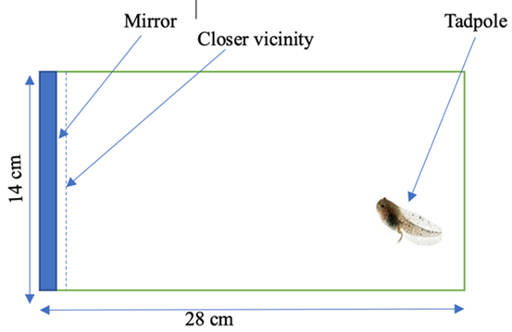 | 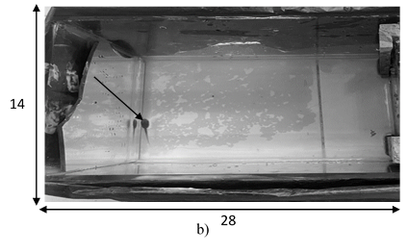  14 cm  28 cm
Amphibian larvae were taken individually and were placed inside the experimental tank which contains a mirror (12 x 5 x 0.5 cm) fitted to one wall of the tank (Figure 2.7 a & b) The tadpole was placed away from the mirror after letting them to stay 3 min of acclimatization time. The behaviour of the amphibian larva was filmed for 5 minutes using the camera. The videos taken were analysed to measure the time spent closer to mirror (CV), number of attacks towards the mirror (AT), time spent near the mirror zone (CM), movements done parallel do the mirror (Expo) and no of avoidances done away from the mirror (Avoid). Exploration, sociability and aggression were measured. After this amphibian larvae were captured and returned to their isolation tanks. Aggression during the mirror test was quantified by recording the number of aggressive acts directed at the mirror image, including lunges, attacks, or striking movements, along with the latency to the first attack and total duration of aggressive behaviour. Exploration was measured by counting the number of non-aggressive approaches toward the mirror, characterized by slow swimming, close inspection from different angles, gentle touching of the mirror, and swimming parallel to the reflection. Latency to the first exploratory approach and total time spent near the mirror without aggression were also recorded as indicators of information gathering rather than confrontation.
- (b)
Figure 2.7 a) Schematic diagram of the arena used for the mirror test b) Photograph taken from the video recording of mirror test of Duttaphrynus melanostictus tadpole

After experiments, tadpoles were euthanized humanely using an immersion dose of MS-222 (tricaine methanesulfonate) at 300 mg/L, buffered to ph 7.0–7.5, following American Veterinary Medical Association (AVMA) and Federation of European Laboratory Animal Science Associations (FELASA) guidelines.

2.4 Data Analysis
All statistical analyses were conducted using R version 3.6.1 (R Core Team, 2021). For each behavioural variable ET, TL, RZ, LA, TS, CV, AT, CM, Avoid and exploration adjusted repeatability (i.e., repeatability estimates after controlling for fixed effects; Nakagawa & Schielzeth, 2010; Pathirana et al., 2025) was calculated by fitting linear mixed-effects models using the R package rptr (Stoffel et al., 2017). Log-transformed ET and TL, as well as RZ, LA, TS, CV, CM, Expo and Avoid were modelled as Gaussian variables, while Attacks was modelled using a Poisson distribution. Individual ID was included as a random effect, with body mass, body length and time point as fixed effects. Repeatability was estimated as the intra-class correlation coefficient (ICC) derived from within-individual and among-individual variance components. Confidence in these estimates was assessed using 1,000 parametric bootstrap replicates to generate 95% confidence intervals (cis). Statistical significance of repeatability was determined by permutation tests of the residuals from the fitted null models, and a trait was considered significantly repeatable only if p < 0.05 in the permutation test and the 95% CI did not include zero.
To examine correlations between behavioural traits, within-individual, among-individual, and overall phenotypic correlations were calculated using multivariate mixed-effects models under a Bayesian framework, implemented in the mcmcglmm package (Hadfield, 2010; Dingemanse & Dochtermann, 2013). Response variables and fixed/random effects were modeled as described above. Models were run for 1,500,000 iterations with a burn-in of 500,000 and a thinning interval of 100. Behavioural correlations were considered significant if the 95% credibility interval (CI) did not include zero.

2.5 Ethical Considerations
Ethical approval for all procedures was obtained from the Ethics Committee of the Postgraduate Institute of Science, University of Peradeniya (Permit No: CEC_PGIS_2025_03). All procedures followed AVMA and FELASA guidelines for the humane treatment and euthanasia of amphibians.

RESULTS

3.1 Repeatability of Behavioural Traits
Short-term analysis of Polypedates cruciger larvae showed significant repeatabilities across most measured putative personality traits; including boldness (except for RZ), and exploration; but excluding activity, sociability and aggression (Table 3.1). Track Length (TL), RZ, CV and AT variables showed repeatability values as zero or near zero and were not statistically significant (Table 3.1). In long-term analysis of P. cruciger larvae; significant repeatabilities were maintained for putative traits boldness (except for RZ), exploration, sociability, and aggression, while activity (TL) and RZ representing boldness remained non-significant (Table 3.1). Among the variables, LA (in both short-term and long-term analysis) and CV and CM in long-term analysis showed particularly high and significant repeatability. Track length (TL) and RZ continued to be non-significant with zero repeatability (Table 3.1).
Several behaviors became substantially more repeatable over longer intervals. Boldness measured as emergence time (ET) decreased from moderate short-term repeatability to a lower long-term value, while avoidance behavior increased markedly, becoming highly repeatable long-term. Exploration traits followed a similar pattern: LA, CM, and general exploration (Expo) all shifted from low-to-moderate short-term repeatability to high long-term consistency. Likewise, sociability (CV) increased from low to high repeatability over time. Aggression showed weak short-term repeatability but moderate long-term consistency. Overall, P. cruciger exhibited stronger long-term stabilization of behavioral traits (Table 3.1).

Personality trait | Behavioral variable | Short-term |  |  | Long-term
 |  | Repeatability | CI value | p value | Repeatability | CI value | p value
Activity | TL | 0 | (0,0.118) | 0.5 | 0 | (0,0.158) | 1
Boldness | RZ | 0 | (0,0.013) | 0.5 | 0 | (0,0.179) | 1
 | ET | 0.454 | (0.284,0.590) | <0.001 | 0.281 | (0.092,0.463) | 0.001
 | Avoid | 0.200 | (0.033,0.308) | 0.005 | 0.652 | (0.489,0.762) | <0.001
Exploration | LA | 0.548 | (0.404,0.669) | <0.001 | 0.822 | (0.727,0.884) | <0.001
 | TS | 0.371 | (0.204,0.506) | <0.001 | 0.295 | (0.102,0.457) | <0.001
 | CM | 0.195 | (0.048,0.328) | 0.002 | 0.877 | (0.797,0.916) | <0.001
 | Expo | 0.176 | (0.033,0.314) | 0.004 | 0.681 | (0.535,0.787) | <0.001
Sociability | CV | 0.124 | (0,0.258) | <0.001 | 0.721 | (0.590,0.816) | <0.001
Aggression | AT | 0.088 | (0,0.230) | 0.099 | 0.288 | (0.153,0.450) | <0.001
Table 3.1 Repeatability estimates (with 95% credible intervals in parentheses) for each personality trait in common hourglass frog (Polypedates cruciger) measured across short-term
Note: Bold text indicates a significant effect (p <.05 in a permutation of residuals test and 95% cis not including zero). Behavioral variables: TL – track length; RZ – time spent in risky zone; ET – emergence time; LA – latency to approach an object; TS – time spent near object; CV – time spent near mirror; AT – number of attacks towards mirror; CM – latency to approach mirror; Avoid – number of avoidances done away from the mirror; Expo – number of movements done parallel to the mirror.
Short-term analysis of Duttaphrynus melanostictus larvae exhibited exceptionally high and significant repeatability values. Specifically, CV (sociability) and LA (exploration) repeatability approaching perfect repeatability (Table 3.2). Emergence Time; ET (boldness), also demonstrated significant repeatability. The behavioral traits such as TS, CM and Avoid too showed significant repeatabilities while TL (activity) and RZ (boldness) showed zero repeatability and were non-significant (Table 3.2).
The long-term analysis of repeatability in D. melanostictus larvae indicated that most personality traits were significant. In the long-term analysis of D. melanostictus AT (aggression) showed the highest repeatability (Table 3.2). Significant repeatabilities were showed for all the others including ET, Avoid (Boldness), LA, TS, CM, Expo (exploration), CV (sociability) and AT (aggression) except TL (activity) and RZ (boldness).
Duttaphrynus melanostictus displayed very high short-term repeatability in several traits, particularly boldness (ET), exploration (LA), and sociability (CV), all of which were close to or above 0.88. However, repeatability in these traits declined substantially over the long term, although they generally remained significant. Exploration measures such as CM and Expo, as well as avoidance behavior, increased modestly from short- to long-term, while aggression shifted from low short-term repeatability to high long-term consistency. Activity and boldness measured by RZ remained non-repeatable in both periods. When comparing species, D. melnostictus showed greater short-term consistency (table 3.2), while P. cruciger demonstrated higher long-term repeatability across a wider set of behaviors.
Personality trait | Behavioral variable | Short-term |  |  | Long-term
 |  | Repeatability | CI value | p value | Repeatability | CI value | p value
Activity | TL | 0 | 0,0.124 | 1 | 0.027 | 0,0.373 | 0.0003
Boldness | RZ | 0 | 0,0.118 | 0.5 | 0 | 0,0.125 | 0.5
 | ET | 0.884 | 0.819,0.921 | <0.001 | 0.379 | 0.225,0.520 | <0.001
 | Avoid | 0.170 | 0.031,0.313 | <0.001 | 0.431 | 0.259,0.560 | <0.001
Exploration | LA | 0.981 | 0.969,0.988 | <0.001 | 0.509 | 0.354,0.627 | <0.001
 | TS | 0.382 | 0.215,0.516 | <0.001 | 0.176 | 0.041,0.322 | 0.004
 | CM | 0.195 | 0.049,0.337 | 0.002 | 0.473 | 0.311,0.601 | <0.001
 | Expo | 0.059 | 0,0.194 | 0.192 | 0.488 | 0.325,0.621 | <0.001
Sociability | CV | 0.996 | 0.994,0.998 | <0.001 | 0.469 | 0.306,0.596 | <0.001
Aggression | AT | 0.093 | 0,0.214 | 0.089 | 0.654 | 0.513,0.748 | <0.001
Table 3.2 Repeatability estimates (with 95% credible intervals in parentheses) for each personality trait in common toad (Duttaphrynus melanostictus) measured across short-term (n = 50) and long-term time periods (n = 50)
Note: Bold text indicates a significant effect (p <.05 in a permutation of residuals test and 95% cis not including zero). Behavioral variables: TL – track length; RZ – time spent in risky zone; ET – emergence time; LA – latency to approach an object; TS – time spent near object; CV – time spent near mirror; AT – number of attacks towards mirror; CM – latency to approach mirror; Avoid – number of avoidances done away from the mirror; Expo – number of movements done parallel to the mirror.
Short-term repeatability differed markedly between P. cruciger and D. melanostictus. Duttaphrynus melanostictus showed consistently higher short-term repeatability across several behaviours, most notably boldness (ET), exploration (LA), and sociability (CV), all of which exhibited very high consistency (≥0.88). In contrast, P. cruciger showed generally low short-term repeatability, with only moderate values observed for ET, LA, TS, and CM. Activity (TL) and boldness (RZ) were non-repeatable in both species. Overall, D. melanostictus displayed much stronger immediate behavioural consistency, indicating that its personality traits are more stable over short temporal scales compared to P. cruciger (See Table 3.1 and 3.2).
Long-term patterns showed the opposite trend. Polypedates cruciger demonstrated substantially higher long-term repeatability across multiple behavioural domains, with exploration traits (LA, CM, Expo) and sociability (CV) showing strong to very strong consistency over time. In contrast, long-term repeatability in D. melanostictus was generally moderate and often lower than its short-term values, except for aggression (AT), which remained high. Although both species showed low long-term repeatability in activity (TL) and boldness (RZ), P. cruciger maintained higher long-term stability across a wider range of behaviours. These results indicate that while D. melanostictus exhibited greater short-term consistency, P. cruciger showed more stable personality expression over longer periods (See Table 3.1 and 3.2).

3.2 Correlations of Behavioural Traits
The correlation analysis for the two amphibian larval species, P. cruciger and D. melanostictus, demonstrated varying degrees and types of significant relationships between behaviors across different time scales. In the short-term analysis of P. cruciger, highly significant correlations were readily apparent (Table 3.3; Fig 3.1a).Emergence time (ET) also showed a positive within individual correlation with exploratory behaviour (Expo), suggesting that faster-emerging individuals explored more. A positive association was also seen between ET and aggression (AT) at both phenotypic and within-individual levels, showing that bolder individuals tended to be more aggressive. Activity (TL) showed positive phenotypic and within-individual correlations with latency to approach (LA), as well as with time spent in the risky zone (TS) and exploratory behaviour (Expo), suggesting that more active larvae were also more exploratory (Table 3.3; Fig 3.1a). Sociability (CV) also showed positive phenotypic and within-individual correlations with exploratory behaviour (Expo). Latency to approach (LA) showed positive phenotypic, within-individual, and among-individual correlations with time in the risky zone (TS), indicating a consistent behavioural link where individuals that explored more also took more risks. Finally, LA exhibited a positive phenotypic correlation with exploratory behaviour (Expo), showing that different types of exploration were positively linked. (Table 3.3; Figure 3.1a).
In the long-term analysis, sociability (CV) showed a positive within-individual correlation with emergence time (ET), suggesting that within individuals, changes in sociability were aligned with changes in boldness. A positive within-individual correlation was also observed between ET and latency to approach (LA). Activity (TL) displayed a positive phenotypic and negative within-individual correlation with sociability (CV), indicating that more active individuals tended to be less social (Table 3.3; Fig 3.1b). A positive phenotypic and within-individual correlation was found between boldness measured by risky-zone use (RZ) and sociability (CV). Exploration (LA) showed positive correlations across phenotypic, within-individual, and among-individual levels with time spent in the risky zone (TS), and exploratory behaviour (Expo), showing broad consistency in exploration-related traits (Table 3.3;Fig 3.1b)
Table 3.3 Within individual, among individual and overall phenotypic correlations (with 95% credible intervals in parentheses) between behavioral variable in common toad (Polypedates cruciger) measured across short-term (n = 50) and long-term time periods (n=50)
Putative personality trait for behavioral variable 1 | Behavioral variable 1 | Putative personality trait for behavioral variable 2 | Behavioral variable 2 | Short-term correlations |  |  | Long-term correlations
 |  |  |  | Phenotypic | Within individual | Among individual | Phenotypic | Within individual | Among individual
Boldness | ET | Activity | TL | -0.082  (-0.209,0.062) | -0.199  (-0.350,-0.049) | 0.987  (-0.997,0.999) | -0.001  (-0.167,0.154) | -0.014  (-0.193,0.159) | 0.859  (-0.999,0.999)
 |  | Boldness | RZ | -0.058  (-0.198,0.085) | -0.046  (-0.204,0.115) | -0.705  (-0.997,0.972) | 0.957  (-0.942,0.999) | 0.021  (-0.159,0.201) | 0.900  (-0.962,0.999)
 |  |  | Avoid | -0.051  (-0.218,0.115) | -0.037  (-0.191,0.117) | -0.068  (-0.372,0,253) | -0.007  (-0.151,0.151) | -0.051  (-0.262,0.156) | 0.424  (-0.427,0,559)
 |  | Sociability | CV | -0.052  (-0.99,0.59) | -0.075  (-0.19,0.15) | 0.341  (-0.95,0.99) | -0.120  (-0.269,0.040) | -0.359  (-0.534,-0.167) | 0.996  (-0.997,0.999)
 |  | Exploration | LA | -0.07  (-0.25,0.11) | -0.14  (-0.29,0.02) | 0.51  (-0.56,0.55) | -0.026  (-0.185,0.139) | 0.248  (0.026,0.445) | -0.996  (-0.999,0.998)
 |  | Exploration | TS | 0.071  (0.017,0.081) | -0.008  (-0.17,0.16) | 0.011  (-0.38,0.43) | 0.023  (-0.133,0.186) | 0.049  (-0.164,0.254) | -0.824  (-0.998,0.995)
 |  |  | Expo | -0.049  (-0.213,0.113) | 0.103  (0.058,0.250) | 0.046  (-0.309,0.416) | 0.023  (-0.133,0.186) | 0.049  (-0.164,0.254) | -0.824  (-0.998,0.995)
 |  |  | CM | 0.476  (0.368,-0.579) | 0.479  (-0.371,0.582) | 0.130  (-0.976,0.998) | 0.066  (-0.070,0.195) | 0.118  (-0.090,0310) | 0.002  (-0.409,0.436)
 |  | Aggression | AT | 0.476  (0.368,0.579) | 0.479  (0.371,0.582) | 0.130  (-0.976,0.998) | -0.026  (-0.185,0.139) | 0.248  (-0.026,0.445) | -0.996  (-0.999,0.998)
Activity | TL | Boldness | RZ | -0.999  (-0.999,0.947) | 0.085  (-0.088,0.014) | -0.014  (-0.153,0.115) | 0.105  (-0.053,0.266) | -0.107  (-0.155,0.269) | -0.160  (-0.999,0.981)
 |  |  | Avoid | 0.108  (-0.028,0.242) | 0.126  (-0.020,0.270) | -0.949  (-0.999,0.990) | -0.007  (-0.142,0.159) | -0.052  (-0.259,0.149) | 0.094  (-0.428,0.543)
 |  | Sociability | CV | -0.024  (-0.162,0.101) | 0.006  (-0.141,0.155) | -0.991  (-0.999,0.995) | 0.124  (0.039,0.272) | -0.357  (-0.532,-0.152) | 0.995  (-0.994,0.999)
 |  | Exploration | LA | 0.243  (0.118,0.369) | 0.279  (0.134,0.419) | 0.142  (-0.367,0.580) | 0.129  (0.064,0.192) | 0.036  (-0.141,0.238) | 0.995  (-0.998,0.999)
 |  |  | TS | 0.156  (0.018,0.257) | 0.223  (0.078,0.360) | 0.000  (-0.976,0.998) | 0.024  (-0.137,0.182) | 0.564  (-0.156,0.265) | -0.909  (-0.999,0.994)
 |  |  | Expo | 0.476  (0.368,0.579) | 0.479  (0.371,0.582) | 0.130  (-0.976,0.998) | 0.066  (-0.070,0.195) | 0.118  (-0.090,0.310) | 0.002  (-0.409,0.436)
Table 3.3 (continued) |  |  | CM | -0.058  (-0.198,0.085) | -0.046  (-0.204,0.115) | -0.705  (-0.997,0.972) | 0.016  (-0.091,0.127) | 0.026  (-0.155,0.209) | 0.023  (-0.469,0.544)
 |  | Aggression | AT | -0.07  (-0.25,0.11) | -0.14  (-0.29,0.02) | 0.51  (-0.36,0.35) | 0.024  (-0.137,0.182) | 0.564  (-0.156,0.265) | -0.909  (-0.960,0.954)
Boldness | RZ | Boldness | Avoid | -0.016  (-0.127,0.092) | -0.023  (-0.179,0.126) | -0.005  (-0.338,0.316) | 0.016  (-0.091,0.127) | 0.026  (-0.155,0.209) | 0.023  (-0.469,0.544)
 |  | Sociability | CV | 0.016  (-0.091,0.127) | 0.026  (-0.155,0.209) | 0.023  (-0.469,0.544) | 0.184  (0.027,0.341) | 0.184  (0.010,0.372) | 0.947  (-0.796,0.999)
 |  | Exploration | LA | 0.016  (-0.091,0.127) | 0.026  (-0.135,0.209) | 0.023  (-0.466,0.544) | 0.104  (-0.063,0.260) | 0.125  (-0.059,0.314) | 0.928  (-0.860,0.999)
 |  |  | TS | -0.024  (-0.162,0.101) | 0.006  (-0.141,0.155) | -0.991  (-0.999,0.997) | 0.019  (-0.145,0.178) | -0.036  (-0.211,0.157) | 0.917  (-0.923,0.999)
 |  |  | Expo | -0.013  (-0.138,0.111) | -0.015  (-0.171,0.131) | -0.019  (-0.495,0.443) | 0.041  (-0.068,0.149) | 0.070  (-0.117,0.247) | 0.015  (-0.428,0.457)
 |  |  | CM | 0.104  (-0.063,0.260) | 0.125  (-0.059,0.314) | 0.928  (-0.860,0.999) | 0.041  (-0.068,0.149) | 0.070  (-0.117,0.247) | 0.015  (-0.428,0.457)
 |  | Aggression | AT | -0.024  (-0.162,0.101) | 0.006  (-0.141,0.155) | -0.991  (-0.999,0.997) | -0.007  (-0.142,0.159) | -0.052  (-0.259,0.149) | 0.094  (-0.428,0.543)
Sociability | CV | Boldness | Avoid | -0.050  (-0.211,0.113) | -0.037  (-0.181,0.129) | -0.069  (-0.365,0.251) | 0.309  (0.104,0.499) | 0.205  (0.009,0.380) | 0.361  (0.075,0.618)
 |  | Exploration | LA | 0.053  (-0.09,0.204) | -0.163  (-0.315,0.225) | 0.993  (-0.967,0.999) | 0.344  (0.121,0.549) | 0.032  (-0.169,0.223) | 0.412  (0.152,0.649)
 |  |  | TS | 0.015  (-0.124,0.152) | 0.023  (-0.146,0.189) | -0.186  (-0.998,0.993) | 0.202  (0.026,0.377) | 0.027  (-0.128,0.258) | 0.551  (0.121,0.998)
 |  |  | Expo | 0.243  (0.118,0.369) | 0.279  (0.134,0.419) | 0.142  (-0.367,0.580) | 0.269  (0.065,0.466) | 0.073  (-0.128,0.258) | 0.361  (0.083,0.624)
 |  |  | CM | 0.041  (-0.068,0.149) | 0.070  (-0.117,0.247) | 0.015  (-0.428,0.457) | 0.142  (-0.367,0.580) | 0.269  (-0.065,0.466) | 0.073  (-0.128,0.258)
 |  | Aggression | AT | -0.013  (-0.138,0.111) | -0.015  (-0.171,0.131) | -0.019  (-0.495,0.443) | 0.184  (0.027,0.341) | 0.184  (0.010,0.372) | 0.947  (-0.796,0.999)
Exploration | LA | Boldness | Avoid | 0.016  (-0.161,0.199) | -0.003  (-0.161,0.199) | 0.033  (-0.277,0.342) | -0.019  (-0.270,0.220) | -0.029  (-0.227,0.159) | -0.020  (-0.329,0.269)
 |  | Exploration | TS | 0.511  (0.388,0.634) | 0.174  (0.125,0.321) | 0.999  (0.959,0.9992) | 0.387  (0.228,0.526) | 0.423  (0.237,0.579) | 0.895  (0.481,0.999)
 |  |  | Expo | 0.177  (0.012,0.344) | 0.124  (-0.027,0.274) | 0.256  (-0.088,0.574) | 0.258  (0.026,0.477) | 0.005  (-0.189,0.198) | 0.318  (0.023,0.561)
 |  |  | CM | 0.177  (-0.011 ,0.344) | 0.124  (-0.027,0.274) | 0.028  (-0.123,0.195) | 0.009  (-0.140,0.164) | 0.065  (-0.303,0.435) | -0.019  (-0.270,0.220)
 |  | Aggression | AT | -0.016  (-0.127,0.092) | -0.023  (-0.179,0.126) | -0.005  (-0.338,0.316) | 0.104  (-0.063,0.260) | 0.125  (-0.059,0.314) | 0.928  (-0.860,0.999)
Exploration | TS | Boldness | Avoid | -0.002  (-0.174,0.162) | -0.007  (-0.169,0.156) | 0.013  (-0.382,0.420) | -0.005  (-0.173,0.175) | -0.003  (-0.206,0.189) | -0.012  (-0.382,0.367)
 |  | Exploration | Expo | 0.028  (-0.123,0.195) | 0.009  (-0.140,0.164) | 0.065  (-0.303,0.435) | 0.044  (-0.123,0.215) | 0.007  (-0.179,0.126) | 0.099  (-0.262,0.441)
 |  |  | CM | 0.013  (-0.382,0.420) | -0.005  (-0.173,0.175) | -0.003  (-0.206,0.189) | -0.012  (-0.382,0.367) | 0.009  (-0.140,0.164) | 0.012  (-0.382,0.367)
 |  | Aggression | AT | -0.013  (-0.138,0.111) | -0.015  (-0.171,0.131) | -0.019  (-0.495,0.443) | -0.019  (-0.270,0.220) | -0.029  (-0.227,0.159) | -0.020  (-0.329,0.269)
Exploration | Expo | Boldness | Avoid | 0.101  (-0.056,0.251) | 0.126  (-0.027,0.270) | 0.068  (-0.245,0.359) | 0.192  (-0.024,0.392) | 0.193  (0.056,0.371) | 0.191  (-0.122,0.470)
 |  | Aggression | AT | -0.050  (-0.211,0.113) | -0.991  (-0.999,0.958) | -0.14  (-0.29,0.302) | 0.104  (-0.263,0.260) | 0.125  (-0.259,0.314) | 0.928  (-0.960,0.999)
 |  | Exploration | CM | 0.013  (-0.382,0.420) | -0.005  (-0.173,0.175) | -0.003  (-0.206,0.189) | 0.009  (-0.140,0.164) | 0.065  (-0.303,0.435) | -0.023  (-0.179,0.126)
Boldness | Avoid | Aggression | AT | -0.07  (-0.25,0.56) | -0.019  (-0.495,0.443) | 0.006  (-0.141,0.155) | 0.044  (-0.123,0.215) | 0.007  (-0.063,0.260) | 0.099  (-0.262,0.441)
 |  | Exploration | CM | -0.007  (-0.169,0.156) | 0.013  (-0.382,0.420) | -0.005  (-0.173,0.175) | 0.028  (-0.123,0.195) | 0.009  (-0.140,0.164) | 0.065  (-0.303,0.435)
Aggression | AT | Exploration | CM | 0.009  (-0.140,0.164) | 0.065  (-0.303,0.435) | 0.044  (-0.123,0.215) | 0.104  (-0.163,0.260) | 0.125  (-0.259,0.314) | 0.928  (-0.960,0.999)
Note: Bold text indicates a significant effect (95% cis not including zero). Behavioral variables: TL – track length; RZ – time spent in risky zone; ET – emergence time; LA – latency to approach an object; TS – time spent near object; CV – time spent near mirror; AT – number of attacks towards mirror; CM – latency to approach mirror; Avoid – number of avoidances done away from the mirror; Expo – number of movements done parallel to the mirror.
Table 3.3 (continued)

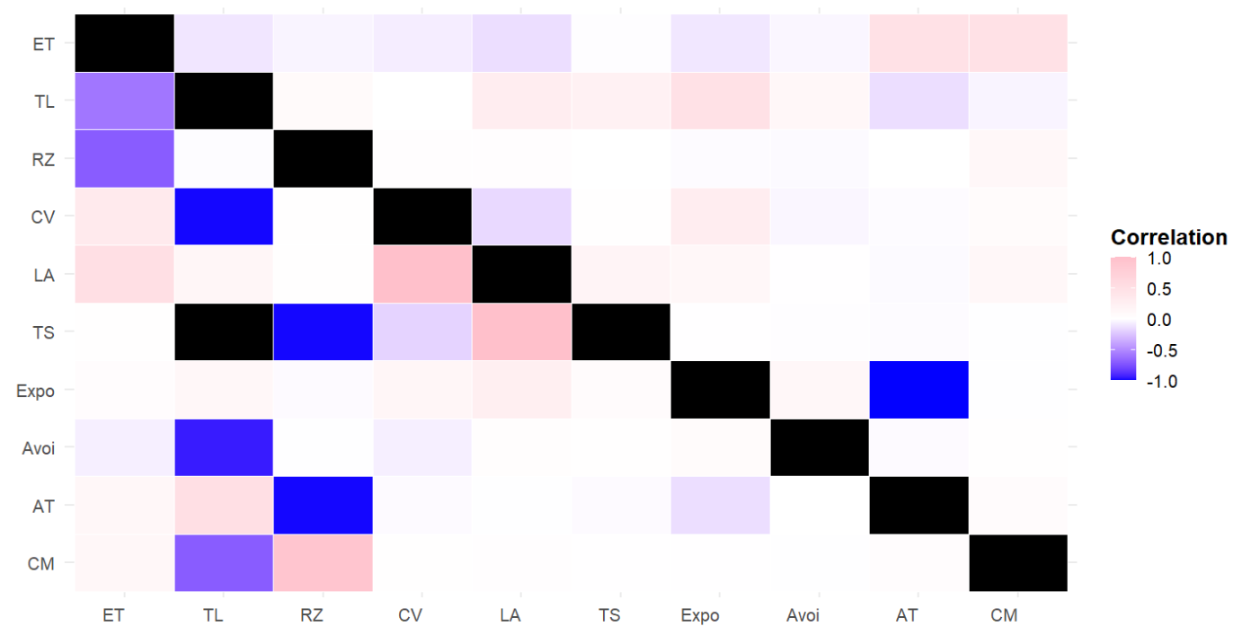

(a)
( (a
Figure 3.1 a) Within-individual (above diagonal) and among-individual (below diagonal) correlations between behavioural variables in Polypedates cruciger short-term time period
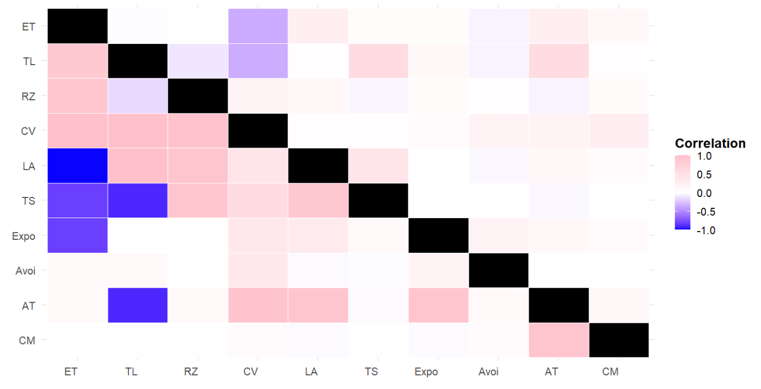
(b)
Figure 3.1 b) Within-individual (above diagonal) and among-individual (below diagonal) correlations between behavioural variables in Polypedates cruciger long- term time period
Note: Behavioral variables: TL – track length; RZ – time spent in risky zone; ET – emergence time; LA – latency to approach an object ; TS – time spent near object; CV – time spent near mirror; AT – number of attacks towards mirror; CM – latency to approach mirror; Avoid – number of avoidances done away from the mirror; Expo – number of movements done parallel to the mirror.
The short-term correlations in D. melanostictus indicated strong linkages between activity, boldness, and exploration. In short-term measurements, emergence time (ET) and (LA) showed positive within-individual and among-individual correlations, indicating that faster-emerging individuals were also more explorative across both scales. Activity (TL) showed a positive phenotypic and within-individual correlation with time spent in the risky-zone (RZ). Latency to approach (LA) showed a positive within-individual correlation with activity (TL). Exploratory behaviour (Expo) displayed a positive within-individual correlation with sociability (CV). Latency to approach (LA) also showed positive among-individual correlations with time spent in the risky zone (TS) (Table 3.4; Fig 3.2a). Exploration (Expo) showed a positive phenotypic correlation with avoidance behaviour. A positive phenotypic, within-individual, and among-individual correlation appeared between exploratory behaviour (Expo) and aggression (AT) (Table 3.4; Figure 3.2a).
The long-term analysis for D. melanostictus continued to show complex correlation structures. In the long term, activity (TL) showed a positive phenotypic and within-individual correlation with risky-zone use (RZ), indicating that more active larvae also tended to display higher boldness. Time spent in the risky zone (RZ) also showed a positive among-individual correlation with exploratory behaviour (Expo) while displaying a positive phenotypic and within-individual correlation with sociability (CV). Sociability (CV) showed a positive phenotypic, within-individual, and among-individual correlation with LA and phenotypic and within-individual correlation with aggression (AT) (Table 3.4; Figure 3.2b) suggesting consistent behavioural linkages across response types. Latency to approach (LA) also displayed positive phenotypic and within-individual correlations with exploratory behavior and phenotypic, within individual and among individual correlations with TS. Activity (TL) showed a positive among-individual correlation with emergence time (ET), indicating a long-term behavioural syndrome linking activity and boldness. Latency to approach (LA) showed a positive phenotypic and within individual correlations with aggression (AT). (Table 3.4; Figure 3.2b). The two amphibian species were showing similar trends in within individual and among individual correlations but there were major differences in the strengths of these correlations (see Figure 3.1 and Figure 3.2).

Table 3.4 Within individual, among individual and overall phenotypic correlations (with 95% credible intervals in parentheses) between behavioral variable in common toad (Duttaphrynus melanostictus ) measured across short-term (n = 50) and long-term time periods (n=50)
Putative personality trait for behavioral variable 1 | Behavioral variable 1 | Putative personality trait for behavioral variable 2 | Behavioral variable 2 | Short-term correlations |  |  | Long -term Correlations
 |  |  |  | Phenotypic | Within individual | Among individual | Phenotypic | Within individual | Among individual
Boldness | ET | Activity | TL | 0.066  (-0.060,0.207) | -0.018  (-0.182,0.142) | 0.996  (-0.989,0.999) | 0.058  (-0.098,0.213) | -0.193  (- 0.341,0.029) | 0.099  (0.095,0.999)
 |  | Boldness | RZ | 0.033  (-0.116,0.176) | 0.049  (-0.009,0.212) | 0.312  (-0.309,0.993) | 0.004  (-0.136,0.150) | -0.084  (-0.229,0.073) | 0.936  (-0.504,0.999)
 |  |  | Avoid | -0.001  (-0.261,0.141) | -0.065  (-0.221,0.091) | -0.076  (-0.385,0.269) | 0.016  (-0.146,0.189) | -0.091  (-0.247,0.062) | 0.145  (-0.188,0.459)
 |  | Sociability | CV | -0.181  (-0.419,0,093) | 0.006  (-0.159,0.161) | -0.194  (-0.448,0,094) | -0.096  (-0.261,0.079) | -0.219  (-0.373,0.064) | 0.092  (-0.314,0.477)
 |  | Exploration | LA | -0.001  (-0.264,0.261) | 0.227  (0.163,0.584) | 0.002  (0.001,0.276) | -0.046  (-0.221,0.125) | -0.062  (-0.219,0.099) | -0.024  (-0.388,0.361)
 |  |  | TS | -0.006  (-0.214,0.185) | 0.001  (-0.163,0.163) | -0.012  (-0.346,0.331) | -0.037  (-0.186,0.108) | -0.028  (-0.202,0.149) | -0.117  (-0.997,0.857)
 |  |  | Expo | -0.072  (-0,278,0.132) | 0.009  (-0.147,0.164) | -0.125  (-0.434,0.203) | 0.024  (-0.156,0.184) | -0.044  (-0.194,0.118) | 0.101  (-0.224,0.415)
 |  |  | CM | 0.104  (-0.063,0.260) | 0.125  (-0.059,0.314) | 0.928  (-0.860,0.999) | 0.002  (-0.175,0.176) | 0.048  (-0.109,0.215) | -0.069  (-0.449,0.316)
 |  | Aggression | AT | -0.019  (-0.216,0.169) | 0.024  (-0.135,0.184) | -0.055  (-0.381,0.279) | -0.003  (-0.179,0.184) | -0.137  (-0.296,0.025) | 0.129  (-0.217,0.481)
Activity | TL | Boldness | Avoid | -0.019  (-0.133,0.100) | -0.017  (-0.261,0.046) | 0.264  (-0.092,0.590) | 0.021  (-0.133,0.164) | 0.098  (-0.055,0.256) | -0.124  (-0.479,0.247)
 |  |  | RZ | 0.052  (0.462,0.653) | 0.566  (0.463,0.654) | 0.084  (-0.957,0.995) | 0.314  (0.178,0.433) | 0.373  (0.238,0.500) | -0.565  (-0.998,0.961)
 |  | Sociability | CV | 0,073  (-0.064,0.202) | -0.001  (-0.163,0.151) | 0.996  (-0.988,0.999) | 0.000  (-0.142,0.149) | 0.119  (-0.163,0.291) | -0.992  (-0.999,0.468)
 |  | Exploration | LA | -0.034  (-0.164,0.105) | 0.167  (0.177,0.319) | -0.994  (-0.999,0.996) | 0.033  (-0.106,0.175) | 0.014  (-0.177,0.201) | 0.930  (-0.999,0.999)
 |  |  | TS | -0.045  (-0.199,0.104) | 0.001  (-0.151,0.170) | -0.205  (-0.709,0.326) | 0.079  (-0.062,0.219) | 0.096  (-0.098,0.268) | -0.114  (-0.997,0.982)
 |  |  | Expo | -0.035  (-0.147,0.083) | -0.046  (-0.194,0.108) | 0.005  (-0.384,0.384) | 0.032  (-0.119,0.166) | 0.078  (-0.083,0.234) | -0.044  (-0.376,0.317)
 |  |  | CM | -0.017  (-0.261,0.046) | 0.264  (-0.092,0.590) | 0.021  (-0.133,0.164) | 0.098  (-0.055,0.256) | 0.119  (-0.163,0.291) | 0.996  (-0.988,0.999)
 |  | Aggression | AT | 0.55  (-0.088,0.202) | 0.089  (-0.033,0.260) | 0.016  (-0.847,0.926) | -0.994  (-0.999,0.996) | 0.033  (-0.106,0.175) | 0.014  (-0.177,0.201)
Boldness | RZ | Boldness | Avoid | -0.124  (-0.391,0.154) | 0.014  (-0.150,0.171) | -0.123  (-0.396,0.156) | 0.036  (-0.069,0.141) | 0.098  (-0.155,0.256) | -0.124  (-0.479,0.247)
Table 3.4 (continued) |  | Exploration | CM | 0.104  (-0.063,0.260) | 0.125  (-0.059,0.314) | 0.928  (-0.860,0.999) | 0.015  (-0.149,0.122) | 0.023  (-0.195,0.162) | 0.000  (-0.999,0.998)
 |  |  | LA | -.0.044  (-0.194,0.095) | 0.153  (-0.006,0.304) | -0.812  (-0.999,0.794) | 0.073  (-0.064,0.214) | 0.018  (-0.050,0.252) | 0.111  (-0.972,0.992)
 |  |  | TS | 0.038  (-0.096,0.178) | 0.087  (-0.064,0.241) | -0.729  (-0.997,0.911) | 0.021  (-0.117,0.158) | 0.028  (-0.116,0.179) | -0.238  (-0.988,0.964)
 |  |  | Expo | -0.066  (-0.178,0.055) | -0.088  (-0.231,0.069) | -0.003  (-0.380,0.386) | 0.078  (-0.018,0.179) | 0.122  (-0.133,0.263) | 0.029  (0.004,0.404)
 |  | Sociability | CV | 0.029  (-0.114,0.175) | 0.006  (-0.150,0.165) | 0.514  (-0.931,0.997) | 0.232  (0.310,0.355) | 0.201  (0.049,0.342) | 0.945  (-0.213,0.999)
 |  | Aggression | AT | 0.110  (-0.004,0.241) | 0.119  (-0.037,0.271) | 0.618  (-0.587,0.975) | 0.111  (-0.013,0.229) | 0.120  (-0.134,0.271) | 0.630  (-0.588,0.970)
Sociability | CV | Boldness | Avoid | 0.097  (-0.112,0.305) | -0.137  (-0.291,0.017) | 0.165  (-0.158,0.480) | 0.319  (0.158,0.479) | 0.348  (0.208,0.487) | 0.297  (-0.016,0.579)
 |  | Exploration | LA | -0.121  (-0.392,0.150) | 0.018  (-0.146,0.174) | -0.112  (-0.394,0.154) | 0.337  (0.175,0.495) | 0.289  (0.134,0.433) | 0.398  (0.059,0.684)
 |  |  | TS | -0.095  (-0.298,0.114) | 0.003  (-0.162,0.159) | -0.161  (-0.486,0.167) | 0.203  (0.058,0.337) | 0.129  (-0.137,0.298) | 0.709  (-0.003,0.998)
 |  |  | Expo | 0.120  (-0.087,0.324) | 0.262  (0.116,0.405) | 0.168  (-0.144,0.469) | 0.272  (0.105,0.434) | 0.265  (0.119,0.411) | 0.287  (-0.026,0.556)
 |  |  | CM | 0.618  (-0.587,0.975) | 0.111  (-0.013,0.229) | 0.120  (-0.034,0.271) | 0.014  (-0.150,0.171) | 0.123  (-0.396,0.156) | 0.036  (-0.069,0.141)
 |  | Aggression | AT | 0.097  (-0.112,0.305) | -0.137  (-0.291,0.017) | 0.165  (-0.158,0.480) | 0.232  (0.051,0.409) | 0.217  (0.063.0.371) | 0.258  (-0.075,0.566)
Exploration | LA | Boldness | Avoid | -0.081  (-0.291,0.122) | -0.009  (-0.163,0.151) | -0.127  (-0.447,0.186) | -0.025  (-0.205,0.160) | 0.032  (-0.127,0.189) | -0.078  (-0.405,0.234)
 |  | Exploration | TS | 0.614  (0.503,0.725) | 0.056  (-0.103,0.213) | 0.995  (0.963,0.999) | 0.424  (0.299,0.539) | 0.348  (0.206,0.499) | 0.938  (0.360,0.999)
 |  |  | Expo | -0.047  (-0.252,0.172) | 0.018  (-0.137,0.173) | -0.078  (-0.403,0.239) | 0.206  (0.015,0.371) | 0.206  (0.057,0.356) | 0.205  (-0.093,0.501)
 |  |  | CM | 0.014  (-0.150,0.171) | -0.123  (-0.396,0.156) | 0.036  (-0.069,0.141) | 0.027  (-0.161,0.211) | 0.050  (-0.108,0.214) | 0.001  (-0.361,0.350)
 |  | Aggression | AT | 0.278  (0.098,0.460) | 0.272  (0.120,0.415) | 0.292  (-0.030,0.579) | 0.280  (0.090,0.480) | 0.271  (0.111,0.408) | 0.295  (-0.023,0.581)
Exploration | TS | Boldness | Avoid | -0.063  (-0.224,0.102) | -0.011  (-0.164,0.148) | -0.146  (-0.475,0.209) | -0.018  (-0.156,0.109) | 0.002  (-0.154,0.161) | -0.085  (-0.461,0.314)
 |  | Exploration | Expo | -0.036  (-0.193,0.133) | -0.001  (-0.162,0.150) | -0.093  (-0.419,0.245) | -0.047  (-0.252,0.172) | 0.018  (-0.137,0.173) | -0.078  (-0.403,0.239)
 |  |  | CM | -0.146  (-0.475,0.209) | -0.018  (-0.156,0.109) | 0.002  (-0.154,0.161) | 0.004  (-0.134,0.159) | 0.024  (-0.150,0.190) | -0.094  (-0.991,0.808)
 |  | Aggression | AT | -0.037  (-0.185,0.106) | 0.004  (-0.167,0.165) | -0.211  (-0.929,0.443) | -0.036  (-0.188,0.106) | 0.004  (-0.154,0.175) | -0.203  (-0.938,0.437)
Exploration | Expo | Boldness | Avoid | 0.174  (0.012,0.333) | 0.113  (-0.038,0.261) | 0.263  (-0.044,0.549) | 0.060  (-0.072,0.191) | 0.072  (-0.077,0.238) | 0.053  (-0.321,0.398)
 |  | Aggression | AT | 0.406  (0.226,0.555) | 0.377  (0.236,0.507) | 0.427  (0.165,0.659) | 0.406  (0.231,0.565) | 0.379  (0.239,0.505) | 0.424  (0.159,0.659)
 |  | Exploration | CM | -0.146  (-0.475,0.209) | -0.018  (-0.156,0.109) | 0.002  (-0.154,0.161) | 0.104  (-0.081,0.277) | 0.126  (-0.129,0.279) | 0.086  (-0.228,0.389)
Boldness | Avoid | Aggression | AT | 0..051  (-0.142,0.249) | 0.074  (-0.082,0.232) | 0.037  (-0.266,0.353) | 0.053  (-0.146,0.247) | 0.074  (-0.079,0.235) | 0.039  (-0.274,0.344)
 |  | Exploration | CM | -0.146  (-0.475,0.209) | -0.018  (-0.156,0.109) | 0.002  (-0.154,0.161) | 0.052  (-0.121,0.239) | 0.111  (-0.052,0.261) | -0.004  (-0.322,0.329)
Aggression | AT | Exploration | CM | -0.0175  (-0.219,0.165) | 0.023  (-0.136,0.183) | -0.052  (-0.380,0,279) | -0.021  (-0.212,0.182) | 0.024  (-0.135,0.183) | -0.057  (-0.387,0.279)
Note: Bold text indicates a significant effect (95% cis not including zero). Behavioral variables: TL – track length; RZ – time spent in risky zone; ET – emergence time; LA – latency to approach an object ; TS – time spent near object; CV – time spent near mirror; AT – number of attacks towards mirror; CM – latency to approach mirror; Avoid – number of avoidances done away from the mirror; Expo – number of movements done parallel to the mirror.
Table 3.4 (continued)

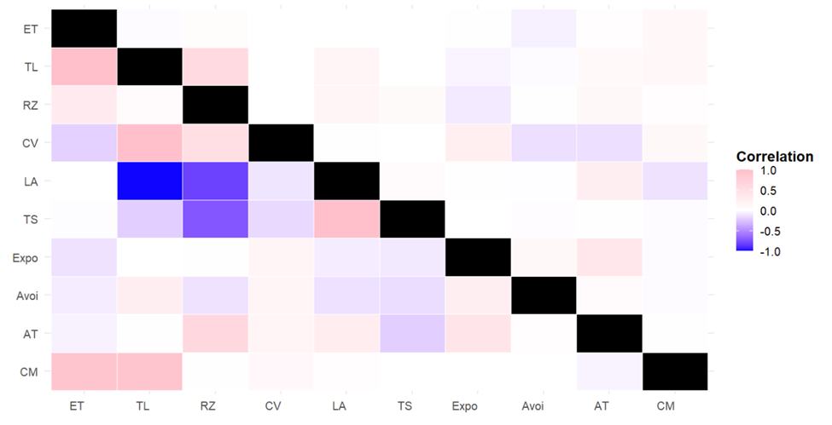
(a)
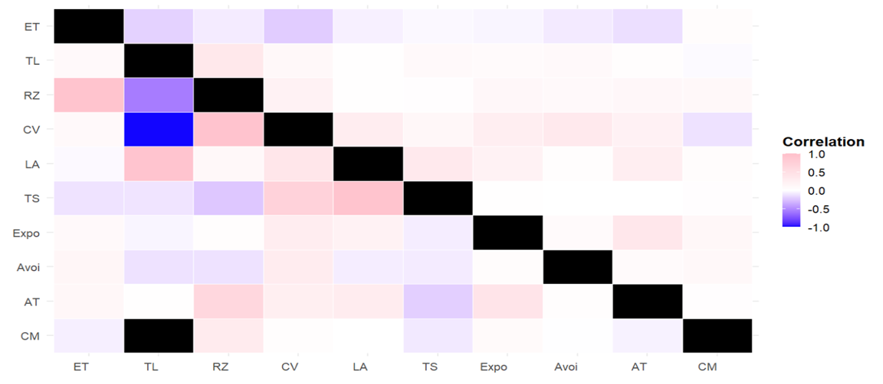
Figure 3.2 a) Within-individual (above diagonal) and among-individual (below diagonal) correlations between behavioural variables in Duttaphrynus melanostictus short-term time period
(b)
Figure 3.2 b) Within-individual (above diagonal) and among-individual (below diagonal) correlations between behavioural variables in Duttaphrynus melanostictus long-term time period
Note: Behavioral variables: TL – track length; RZ – time spent in risky zone; ET – emergence time; LA – latency to approach an object ; TS – time spent near object; CV – time spent near mirror; AT – number of attacks towards mirror; CM – latency to approach mirror; Avoid – number of avoidances done away from the mirror; Expo – number of movements done parallel to the mirror.

DISCUSSION
Overall, this study provides the first comprehensive assessment of personality traits and behavioural syndrome structure in the larvae of Polypedates cruciger and Duttaphrynus melanostictus. By combining repeatability analyses across short and long temporal scales with detailed phenotypic, within-individual, and among-individual correlations, the study demonstrates that amphibian larvae exhibit consistent individual differences in behaviour. However, the strength, stability, and integration of these behaviours differ markedly between species. Polypedates cruciger showed low short-term but high long-term stability in exploration, sociability, and aggression, suggesting consolidation of behavioural traits over development. In contrast, D. melanostictus displayed exceptionally high repeatability in the short term - especially in exploration, sociability, and boldness - but weaker long-term stability, pointing to a behavioural strategy characterised by short-term rigidity but long-term flexibility. Across both species, activity and risky-zone use remained non-repeatable, indicating high behavioural plasticity or measurement limitations for these traits. Correlation analyses revealed complex behavioural syndromes, with proactive-like trait combinations appearing more strongly in P. cruciger, while D. melanostictus showed a more diffuse pattern of behavioural integration. These differences have ecological significance, particularly in relation to competitive dynamics, responsiveness to environmental stressors, and potential implications for conservation and management of amphibian populations.
Understanding consistent individual variation in behaviour is central to modern behavioural ecology, as such variation influences survival, competitive performance, and ecological interactions across species (Reale et al., 2007; Sih et al., 2004; Wolf and Weissing, 2012). The present study offers an in-depth evaluation of behavioural repeatability and syndrome structure in two Sri Lankan amphibian larvae, providing new insight into the emergence of personality traits during early development. Importantly, the results show that amphibian larvae are not behaviourally uniform. Instead, they express stable, individual-specific tendencies that persist over time, though to different degrees depending on species and trait type. This supports the growing recognition that personality begins early in ontogeny and can shape ecological outcomes even before metamorphosis (Stamps and Groothuis, 2010; Walls and Gabor, 2019; Pathirana et al., 2025).
In P. cruciger, long-term repeatability was high for exploration (LA, TS, CM, Expo), sociability (CV), and some aspects of boldness, whereas short-term values were comparatively lower. This pattern indicates that certain behavioural dispositions may strengthen or stabilise through development, perhaps reflecting increasing consistency in foraging, sensory processing, or social interactions as larvae grow. Conversely, behaviours linked to activity (TL) and risky-zone use (RZ) showed zero repeatability in both periods. The lack of repeatability in these behaviours mirrors findings in many fish and amphibian studies where movement-based or spatial-positioning metrics show high within-individual variability and low across-individual consistency (Toms et al., 2010; Conrad et al., 2011). This suggests that some behavioural measures may be more sensitive to momentary conditions or internal states, such as hunger or perceived threat, and therefore weaker proxies for personality.
Duttaphrynus melanostictus displayed the opposite temporal pattern. The species showed extremely high repeatability in the short term for exploration, sociability, and boldness, with some values approaching perfect repeatability. Such striking short-term consistency has been reported in studies where behavioural traits are closely tied to physiological state or immediate responses to stimuli (Conrad et al., 2011; Downs et al., 2014). However, long-term repeatability declined substantially across almost all traits. This suggests a behavioural strategy that is consistent over short durations but more flexible in the long term, possibly allowing individuals to adjust behavioural responses as environments shift. This flexibility could be advantageous in unpredictable habitats, where variable hydrology, fluctuating predation pressure, or shifting resource availability require behavioural adjustment (Koolhaas et al., 1999; Niemela and Dingemanse, 2018).
Taken together, these temporal patterns highlight distinct behavioural strategies between the two species. Polypedates cruciger follows a strategy of long-term consistency, which may enhance performance in stable lentic habitats where predictable conditions favour consistent foraging and competitive strategies. In contrast, D. melanostictus expresses short-term behavioural stability combined with long-term plasticity, making it potentially more adaptable in environments that fluctuate or where rapid developmental adjustments are required.
The hierarchical partitioning of covariance confirmed the existence of complex behavioral syndromes aligned with the theoretical proactive-reactive personality axis (Koprivnikar et al., 2012; Sih et al., 2004). The consistent among-individual correlation linking Exploration and Sociability in P. cruciger confirms a stable, proactive strategy. This proactive profile aligns with the Pace-of-Life Syndrome (POLS) hypothesis (Godin et al., 2012; Dammhahn et al., 2018), which links consistent proactive behavior (active, bold) to faster life histories. In Rana dalmatina, support for POLS was found as highly active tadpoles developed faster and metamorphosed earlier can be taken as an example.
Furthermore, our models detected instances of joint plasticity (significant within-individual correlations). For example, negative within-individual correlations were found between boldness (ET) and sociability (CV), and between activity (TL) and sociability (CV) in P. cruciger long-term analysis. These patterns likely reflect short-term internal trade-offs in immediate risk or energetic allocation across different contexts (Downs & Dochtermann, 2014).
We also found support that behavioral precision, quantified as Intra-Individual Behavioural Variation (IIV), is relevant to life history. The finding that low Intra-Individual Behavioural Variation (IIV) in activity correlates with higher relative growth rates in predictable environments (supporting a high pace-of-life strategy, as observed in Rana dalmatina), provides context for the competitive dynamics between the Sri Lankan anurans. The endemic P. cruciger, confirmed as the superior competitor that reduces D. melanostictus growth, maintains a stable, proactive personality profile. This high stability suggests low IIV and supports its efficient, successful strategy for resource exploitation. In sharp contrast, the inferior competitor, D. melanostictus, exhibits highly transient behavioral consistency, with its exploration repeatability.
Importantly, the disparity between phenotypic and among-individual correlations highlights the limitations of inferring behavioural syndromes solely from overall phenotypic data (Brommer, 2013; Dingemanse et al., 2012). Phenotypic correlations often masked underlying individual-level patterns. For example, in the study comparing fish species, phenotypic and among-individual correlations were largely concordant in direction but differed markedly in strength; the phenotypic correlations were always much smaller in magnitude. If researchers had only examined phenotypic correlations, they likely would have made incorrect inferences about the occurrence or true strength of behavioral syndromes in these amphibian larvae. This strongly emphasizes the need for hierarchical partitioning of covariance using multivariate mixed-effects models for accurately characterizing personality structures in amphibians (Dingemanse & Dochtermann, 2013; Pathirana et al., 2025; Pathirana et al., 2024; Brommer & Class, 2017).
Correlation analyses provided further insight into the organisation of behavioural syndromes. Both species exhibited complex networks of correlated behaviours, but the strength and structure of these networks differed. In P. cruciger, exploration traits (LA, TS, Expo) were consistently and strongly correlated with sociability (CV) at phenotypic, within-individual, and among-individual levels, revealing a clear proactive-like behavioural profile. This behavioural axis aligns with the proactive-reactive personality framework and the pace-of-life syndrome (POLS), where proactive individuals are typically more active, exploratory, bold, and competitive, and often linked to faster growth and high metabolic rates (Dammhahn et al., 2018; Sih et al., 2004). The presence of strong among-individual correlations suggests that these patterns reflect stable differences between individuals, rather than transient states or environmental effects.
Within-individual correlations uncovered additional layers of behavioural organisation in P. cruciger. Negative correlations, such as those between activity and sociability or between boldness (ET) and sociability, suggest short-term behavioural trade-offs. These likely reflect immediate constraints in risk allocation or energy expenditure, where increases in a particular behaviour necessitate compensatory decreases in another (Downs and Dochtermann, 2014). These within-individual dynamics highlight the importance of analysing multiple levels of behavioural covariance, as phenotypic correlations alone mask the underlying contributions of individual variation.
Phenotypic correlations often misrepresented the true strength or direction of behavioural syndromes in both species, reinforcing known limitations of relying on surface-level behavioural associations (Brommer, 2013; Dingemanse et al., 2012). For example, several behavioural correlations were weak or non-significant phenotypically but strong at the among-individual level. If only phenotypic correlations had been considered, researchers might have incorrectly concluded that behavioural syndromes were absent or weak. The results therefore emphasise the need for multivariate mixed-effects approaches to accurately partition sources of covariance and reveal the true architecture of behavioural syndromes (Dingemanse and Dochtermann, 2013; Brommer and Class, 2017; Pathirana et al., 2025).
The ecological relevance of these findings becomes clear when viewed in the context of species interactions and competition. Previous research shows that P. cruciger is a superior competitor to D. melanostictus, with the presence of P. cruciger reducing the growth and development of D. melanostictus larvae while benefitting its own growth when reared together (Ukuwela and Ranawana, 2011). The behavioural results of this study provide a mechanism for these ecological outcomes. The proactive personality profile of P. cruciger, characterised by high and stable exploration and sociability, likely enhances resource acquisition and spatial dominance. Such traits promote feeding efficiency and competitive interference, particularly in lentic habitats where food distribution can be patchy (Alford, 1999). In comparison, the behavioural flexibility of D. melanostictus may confer advantages in environments where conditions fluctuate, but is less effective in direct competitive scenarios where consistent and assertive behavioural strategies prevail.
Additionally, differences in larval ecology between the species help explain the observed behavioural patterns. Polypedates cruciger is a lentic, macrophagous nektonic tadpole, physiologically and behaviourally adapted to occupy the open water column where exploratory and active behaviours are advantageous (Altig and Johnston, 1989). Duttaphrynus melanostictus, on the other hand, typically occupies benthic or littoral zones, where environmental heterogeneity may select for behavioural flexibility rather than consistency. Thus, the repeatability and syndrome differences observed in this study are consistent with the ecological specialisations and competitive interactions documented for these species.
The results also have broader ecological and conservation implications. Amphibians are widely recognised as sensitive bio-indicators due to their permeable skin and reliance on aquatic environments (Burlibasa et al., 2011; Muller et al., 2015). Behavioural traits such as exploration, boldness, and activity influence exposure to pollutants, predation risk, and habitat quality. Proactive individuals may be more susceptible to contaminants due to increased movement and risk-taking, while reactive individuals may avoid polluted or dangerous microhabitats. Understanding baseline behavioural patterns can therefore improve detection of early behavioural disruptions caused by sub-lethal stressors such as pesticide runoff, heavy metal contamination, or altered hydrology.
Behavioural traits can also influence the success of conservation actions. For example, translocation programs or captive breeding initiatives may inadvertently select for particular behavioural types, potentially reducing behavioural diversity or altering fitness outcomes in the wild (Attard et al .,2016; Merick et al 2017). Endemic species like P. cruciger may be particularly susceptible to such effects. Integrating behavioural assessments into management planning can help ensure that reintroduced or captive-bred individuals possess behavioural profiles suited to surviving in natural habitats.
Despite its comprehensive scope, this study has several limitations that should be addressed in future research. First, the behavioural assays were conducted under controlled laboratory conditions, which, although necessary for standardisation, may not fully represent the complexity of natural habitats where predation cues, fluctuating resource availability, and variable microclimates can influence behavioural expression and repeatability. Incorporating semi-natural or in-situ behavioural trials would help validate whether the observed personality traits persist under ecologically realistic conditions. Second, while short- and long-term intervals were examined, a more continuous sampling regime across developmental stages would provide clearer insight into when behavioural traits stabilise or reorganise during ontogeny. Third, physiological or neuroendocrine correlates of behaviour were not measured; integrating metabolic rate, stress hormones, or sensory traits could clarify the mechanisms underpinning both species’ behavioural strategies. Finally, the sample size, though adequate for mixed-effects modelling, may limit the detection of weaker behavioural syndromes. Expanding sampling across multiple populations and habitats would allow researchers to test how environmental gradients, genetic structure, and anthropogenic stressors shape behavioural consistency and covariance. Addressing these limitations will deepen our understanding of amphibian personality development and improve predictions of how behavioural variation interacts with ecological change and conservation management.
In conclusion, this study demonstrates that larval stages of P. cruciger and D. melanostictus express distinct personality traits and behavioural syndromes that differ in strength, stability, and organisation. Polypedates cruciger exhibited stable long-term behavioural architecture, while D. melanostictus showed high short-term consistency and long-term flexibility. These findings contribute to a deeper understanding of amphibian behavioural ecology, competition, and developmental plasticity. Future research should explore how these behavioural patterns influence survival and metamorphic success, how they change across ontogeny, and how environmental disturbances modify behavioural consistency. Long-term field studies, cross-stage assessments, and ecological experiments under natural conditions will further clarify the role of personality in amphibian ecology and conservation.

REFERENCES

Adams, E., Leeb, C., & Brühl, C. A. (2021). Pesticide exposure affects reproductive capacity of common toads (Bufo bufo) in a viticultural landscape. Ecotoxicology, 30(2), 213–223.
Alford, R. A., & Richards, S. J. (1999). Global amphibian declines: A problem in applied ecology. Annual Review of Ecology and Systematics, 30, 133–165.
https://doi.org/10.1146/annurev.ecolsys.30.1.133
Altig, R., & Johnston, G. F. (1989). Guilds of anuran larvae: relationships among developmental modes morphologies and habitats. Herpetological Monographs, 3, 81–109.
Attard, C. R. M., Möller, L. M., Sasaki, M., Hammer, M. P., Bice, C. M., Brauer, C. J., Carvalho, D. C., Harris, J. O., & Beheregaray, L. B. (2016). A novel holistic framework for genetic-based captive-breeding and reintroduction programs. Conservation Biology, 30, 1060–1069.
Bègue, L., & Vezirian, K. (2024). Instrumental harm toward animals in a Milgram-like experiment in France: The role of nonpathological personality traits. In H. C. Chan & R. W. Y. Wong (Eds.), Animal abuse and interpersonal violence: A psycho-criminological understanding (pp. 111–127).
Bell, A. M. (2007). Future directions in behavioural syndromes research. Proceedings of the Royal Society B: Biological Sciences, 274, 755–761.
Bell, A. M., Hankison, S. J., & Laskowski, K. L. (2009). The repeatability of behaviour: a meta-analysis. Animal Behaviour, 77, 771–783.
Biro, P. A., & Post, J. R. (2008). Rapid depletion of genotypes with fast growth and bold personality traits from harvested fish populations. Proceedings of the National Academy of Sciences of the United States of America, 105 (8).
https://doi.org/10.1073/pnas.0708159105.
Brommer, J. E., & Class, B. (2017). Phenotypic correlations capture between-individual correlations underlying behavioral syndromes. Behavioral Ecology and Sociobiology, 71, 50.
Burlibaşa, L., Cucu, N., & Gavrilă, L. (2005). Amphibians as model organisms for studying the dynamics of eukaryote genetic material architecture. Wildlife Biology in Practice, 1(1), 24–32.
Burlibaşa, L., & Gavrilă, L. (2011). Amphibians as model organisms for study environmental genotoxicity. Applied Ecology and Environmental Research,9(1),1–15. https://doi.org/10.15666/aeer/0901_001015
Conrad, J. L., Weinersmith, K. L., Brodin, T., Saltz, J. B., & Sih, A. (2011). Behavioural syndromes in fishes: A review with implications for ecology and fisheries management. Journal of Fish Biology, 78, 395–435.
Crews, D., & McLachlan, J. A. (2006). Epigenetics, evolution, endocrine disruption, health, and disease. Endocrinology, 147 (6 Suppl), S4–S10.
https://doi.org/10.1210/en.2005-1122.
Dammhahn, M., Dingemanse, N. J., Niemelä, P. T., & Réale, D. (2018). Pace-of-life syndromes: A framework for the adaptive integration of behaviour, physiology and life history. Behavioral Ecology and Sociobiology, 72, 62.
Dingemanse, N. J., & Dochtermann, N. A. (2013). Quantifying individual variation in behaviour: Mixed-effect modelling approaches. Journal of Animal Ecology, 82, 39–54.
Dingemanse, N. J., Kazem, A. J. N., Reale, D., & Wright, J. (2010). Behavioural reaction norms: animal personality meets individual plasticity. Trends in Ecology & Evolution, 25, 81–89.
Downs, C. J., & Dochtermann, N. A. (2014). Testing hypotheses in eco-immunology using mixed models: Disentangling hierarchical correlations. Integrative and Comparative Biology, 54(3), 407–418.
Ferrari, C., Pasquaretta, C., Carere, C., Cavallone, E., von Hardenberg, A., & Réale, D. (2013). Testing for the presence of coping styles in a wild mammal. Animal Behaviour, 85, 1385–1396.
Frederick, J. L. (1997). Evaluation of fluorescent elastomer injection as a method for marking small fish. Bulletin of Marine Science, 61 (2), 399–408.
Godin, J. G. J., Le Roy, A., Burns, A. L., Seebacher, F., & Ward, A. J. (2022). Pace-of-life syndrome: Linking personality, metabolism and colour ornamentation in male guppies. Animal Behaviour, 194, 13–33.
Hadfield, J. D. (2010). MCMC methods for multi-response generalized linear mixed models: The MCMCglmm R package. Journal of Statistical Software, 33 (2), 1–22.
Herczeg, G., Garamszegi, L. Z. (2012). Individual deviation from behavioural correlations: a simple approach to study the evolution of behavioural syndromes. Behavioral Ecology and Sociobiology, 66, 161–169.
Herczeg, G., Gonda, A., & Merilä, J. (2009). Predation mediated population divergence in complex behaviour of nine-spined stickleback (Pungitius pungitius). Journal of Evolutionary Biology, 22 (3), 544–552.
IUCN (International Union for Conservation of Nature). (2023).The IUCN Red List of Threatened Species (Version 2023-1).
Kelleher, S. R., Silla, A. J., & Byrne, P. G. (2018). Animal personality and behavioral syndromes in amphibians: a review of the evidence, experimental approaches, and implications for conservation. In Behavioral Ecology and Sociobiology (Vol. 72, Issue 5). https://doi.org/10.1007/s00265-018-2493-7.
Koolhaas, J. M., Korte, S. M., De Boer, S. F., Van der Vegt, B. J., Van Reenen, C. G., Hopster, H., De Jong, I. C., Ruis, M. A. W., & Blokhuis, H. J. (1999). Coping styles in animals: current status in behaviour and stress-physiology. Neuroscience & Biobehavioral Reviews, 23(7), 925–935.
https://doi.org/10.1016/S0149-7634(99)00026-3.
Koprivnikar, J., Gibson, C. H., & Redfern, J. C. (2012). Infectious personalities: Behavioural syndromes and disease risk in larval amphibians. Proceedings of the Royal Society B: Biological Sciences, 279 (1733).
https://doi.org/10.1098/rspb.2011.2156.
Lessells, C. M., & Boag, P. T. (1987). The measurement of repeatability. Biological Journal of the Linnean Society, 32 (3), 325–345.
Martins, C. I. M., Galhardo, L., Noble, C., Damsgård, B., Spedicato, M. T., Zupa, W., Beauchaud, M., Kulczykowska, E., Massabuau, J.-C., Carter, T., Rey Planellas, S., & Kristiansen, T. (2012). Behavioural indicators of welfare in farmed fish. Fish Physiology and Biochemistry, 38(1), 17–41.
Merrick, M. J., & Koprowski, J. L. (2017). Should we consider individual behavior differences in applied wildlife conservation studies? Biological Conservation, 209, 34–44..
Mueller, W. A., Hassel, M., & Grealy, M. (2015). Metamorphosis and its hormonal control. In Development and Reproduction in Humans and Animal Model Species (pp. 379–398). Springer.
Nakagawa, S., & Schielzeth, H. (2010). Repeatability for Gaussian and non-Gaussian data: A practical guide for biologists. Biological Reviews, 85, 935–956.
Niemelä, P. T., & Dingemanse, N. J. (2018). Meta-analysis reveals weak associations between intrinsic state and personality. Proceedings of the Royal Society B, 285 (1873), 20172823. https://doi.org/10.1098/rspb.2017.2823
Pathirana, N. U. K., Gleiss, A., Beatty, S. J., & Lymbery, A. J. (2024). Identifying personality traits and behavioural syndromes in a threatened freshwater fish (Nannoperca vittata) through comparative analysis with a model species (Poecilia reticulata): Implications for conservation. Ecology of Freshwater Fish, 00, e12807.
https://doi.org/10.1111/eff.12807.
Pethiyagoda, R., Manamendra-Arachchi, K., Bahir, M.M. & Meegaskumbura, M., 2006. Sri Lankan amphibians: diversity, uniqueness and conservation. Fauna of Sri Lanka. Status of Taxonomy, Research and Conservation, pp.125–133.
Polverino, G., Ruberto, T., Staaks, G., & Mehner, T. (2016). Tank size alters mean behaviours and individual rank orders in personality traits of fish depending on their life stage. Animal Behaviour, 115
R Core Team. (2021). R: A language and environment for statistical computing, R Foundation for Statistical Computing.
Réale, D., Dingemanse, N. J., Kazem, A. J., & Wright, J. (2010). Evolutionary and ecological approaches to the study of personality. Philosophical Transactions of the Royal Society B: Biological Sciences, 365, 3937–3946.
Réale, D., Reader, S. M., Sol, D., McDougall, P. T., & Dingemanse, N. J. (2007). Integrating
Reddon, A. R., Balk, D., & Balshine, S. (2011). Sex differences in group-joining decisions in social fish. Animal Behaviour, 82(2), 229–234.
https://doi.org/10.1016/j.anbehav.2011.04.017
Stoffel, M. A., Nakagawa, S., & Schielzeth, H. (2017). rptR: Repeatability estimation and variance decomposition by generalized linear mixed-effects models. Methods in Ecology and Evolution, 8, 1639–1644.
https://doi.org/10.1111/2041-210X.12797
Szuroczki, D., & Richardson, J. M. L. (2012). The behavioral response of larval amphibians (Ranidae) to threats from predators and parasites. PLoS ONE, 7 (11), e49592. https://doi.org/10.1371/journal.pone.0049592.
Sih, A., Bell, A. M., & Johnson, J. C. (2004). Behavioral syndromes: an integrative overview. Quarterly Review of Biology, 79 (3), 241–277.
Sih, A., Cote, J., Evans, M., Fogarty, S., & Pruitt, J. (2012). Ecological implications of behavioural syndromes. Ecology Letters, 15, 278–289.
Sih, A., Kats, L. B., & Maurer, E. F. (2003). Behavioural correlations across situations and the evolution of antipredator behaviour in a sunfish-salamander system. Animal Behaviour, 65 (1), 29–44.
Smith, B. R., & Blumstein, D. T. (2008). Fitness consequences of personality: a meta-analysis. Behavioral Ecology, 19 (2), 448–455.
K. R. Solomon et al. (Eds.), Environmental fate and safety management of agrochemicals (pp. 124–137). ACS Symposium Series, Vol. 899.
Stamps, J. A., Briffa, M., & Biro, P. A. (2012). Unpredictable animals: individual differences in intraindividual variability (IIV). Animal Behaviour, 83 (5), 1325–1334.
Stoffel, M. A., Nakagawa, S., & Schielzeth, H. (2017). rptR: Repeatability estimation and variance decomposition by generalized linear mixed-effects models. Methods in Ecology and Evolution, 8 (11), 1639–1644.
Toms, C. N., Echevarria, D. J., & Jouandot, D. J. (2010). A methodological review of personality-related studies in fish: Focus on the shy-bold axis of behavior. International Journal of Comparative Psychology, 23, 1–25.
Ukuwela, K. D. B., & Ranawana, K. B. (2011). The presence of Polypedates cruciger tadpoles reduces the growth of Duttaphrynus melanostictus tadpoles under laboratory conditions. Herpetology Notes, 4, 155–158.
Urszán, T. J., Török, J., Hettyey, A., Garamszegi, L. Z., & Herczeg, G. (2015). Behavioural consistency and life history of Rana dalmatina tadpoles. Oecologia, 178(1). https://doi.org/10.1007/s00442-014-3207-0.
Waddington, C. H. (1953). Genetic assimilation of an acquired character. Evolution, 7(2), 118–126.
https://doi.org/10.1111/j.1558-5646.1953.tb00070.x
Walls, S. C., & Gabor, C. R. (2019). Integrating behavior and physiology into strategies for amphibian conservation. Frontiers in Ecology and Evolution, 7, Article 234.
Wilson, A. D., & Krause, M. J. (1994). Personality and metamorphosis: is behavioral variation consistent across ontogenetic niche shifts? Behavioral Ecology, 23 (6), 1316–1323.
Wolf, M., & Weissing, F. J. (2012). Animal personalities: consequences for ecology and evolution. Trends in Ecology & Evolution, 27 (8), 452–461.
https://doi.org/10.1016/j.tree.2012.05.001.

